Antinet Zettelkasten Guide
  - Core, workflows, examples, templates, and application blueprint

Darrell Barrow
July 10, 2026

Purpose of this document
Application structure guide - not a book-only system, not a document store, and not framework code
This guide defines the core operating structure the application should follow before screens, folders, database models, or React components are finalized.
The goal is one general-purpose personal Zettelkasten for Bible study, culinary work, blogging, essays, articles, fiction, poetry, photography, tech notes, lexicons, ciphers, and other knowledge work.
The book-to-zettel workflow is only one use case. It should not control the whole app design.

Table of Contents
Contents
Table of Contents 3
Part 1 — Core Operating System 11
Purpose and Boundary 11
Core Flow 11
Digital Zettelkasten Core Setup 11
Source basis from Zettelkasten.de 11
1. The Core System: what must exist in the application 12
Core objects and their job 12
2. Principle-to-application translation 13
3. The core zettel card layout 13
Required sections on the zettel screen 14
4. Connection setup 14
5. Structure notes: the app’s map layer 15
Structure notes requirements 15
6. Entry points: how you find your way in 16
7. Required workflow in the application 16
Screen behavior checklist 16
8. Domain-neutral zettel examples for the app 17
9. Rules that prevent rebuilding the app repeatedly 18
10. Final app blueprint 18
Sources used 18
Antinet Zettelkasten Master Core Guide 18
Top-Down Map 18
1. Core Four-Record Rule 19
Record Roles: Do Not Call Everything a Note 19
5. Connection Setup: The Link Needs a Reason 20
6. ID Prefix System and Automatic ID Generator 21
7. Worked Examples Using Your Own Data 21
7.1 AeroGarden School Forum Blog Post 21
7.2 Aeroponics and Sustainability Link 22
7.3 Culinary Recipe and Sustainability 22
7.4 Bible Study: Queen of Heaven 22
7.5 Poetry: Phrase, Image, and Finished Poem 22
7.6 Between Realms: Character Profile vs Entity vs Zettel 23
Book and Fiction Workflow Layer: Turning Your Books Into a Zettelkasten 23
1. Start With a Source Note 23
2. Use Fiction-Friendly Note Types 24
3. Build a Simple ID System 24
4. Create Hub Notes First 24
5. Turn Chapters Into Event Cards, Not Summaries 25
6. Example Notes From Emperors Earth 25
Character Note Example 25
Theme Note Example 26
Canon Rule Note Example 26
7. Practical Workflow for Finished Books 26
8. Practical Workflow for New Books 27
9. Suggested Fields for Your Zettelkasten App 27
10. Strong First Pass for Emperors Earth 27
11. Blank Templates 28
Character Note Template 28
Event Note Template 28
Theme Note Template 29
Canon Rule Note Template 29
12. Book-Specific Item Types and Storage Rule 29
13. Example Life Stones Zettel IDs 29
8. Application Areas and Screen Labels 30
9. Migration Plan for Existing Records 30
10. Minimal Templates 31
10.1 Fleeting / Inbox Template 31
10.2 Archived Source Template 31
10.3 Entity Template 31
10.4 Zettel Template 31
10.5 Connection Template 32
10.6 Structure Note Template 32
10.7 Output Template 32
11. Final Checks Before Creating a Record 32
Archived Source to Zettel Core Setup 33
1. The Core Separation 33
2. Where Copied Material Belongs 33
3. Correct Workflow 34
4. Archived Source Template 34
5. Zettel Template 34
6. Connection Template 35
7. Worked Example: Aeroponics Article 35
A. Archived Source 35
B. Zettel created from the source 35
C. Connection from this zettel 36
8. Mapping to the Current App 36
9. Practical Migration Rule 36
10. Final Non-Negotiable Rules 37
Core Digital Zettelkasten Application Setup 37
1. Application Core Folder Setup 37
2. Core Database Relationship Map 38
Core Model File Set and User-Based Rules 39
12. Core Application Model Structure (Models Only) 39
13. Zettel Type Capture Rule 40
14. Required NoteType Seed Values 41
15. How Book-Specific Items Are Stored 41
16. Core Model Files Needed to Build the System 41
16.1 Model File List 41
16.2 What Each Model Does 41
16.3 User-Based App Rule 42
16.4 IdSequence Rule 42
3. Core Mongoose Models 42
backend/models/Project.js 42
backend/models/Source.js 42
backend/models/Entity.js 42
backend/models/Zettel.js 43
backend/models/ZettelLink.js 43
backend/models/StructureNote.js 43
backend/models/Attachment.js 44
backend/models/BackupLog.js 44
4. Domain-Neutral Controlled Values 44
5. Backend Route Map 45
6. Minimal Route File Pattern 45
7. server.js Route Registration 45
8. Frontend Page Responsibilities 45
9. Frontend Form Field Setup 46
10. MVP Build Order 46
11. App Rules That Prevent Document-Store Drift 46
12. Required Views for a True Core 46
Graph Layer: Filtered Views, Not the Entire Database 46
12.1 Core Graph Rule 47
12.2 Graph View Types 47
12.3 Default Graph Behavior 47
12.4 Graph Filters 47
12.5 Practical App Behavior 47
12.6 Simple Rule for Backlinks, Structure Notes, and Graphs 47
13. Minimum API Query Support 48
14. Backup and Export Core 48
15. Final Core Definition 48
Core Digital Zettelkasten System 48
Purpose 48
Core Principle 49
Main Layers 49
Core Data Models 49
Project Model 49
Source Model 50
Zettel Model 50
Domain-Neutral Note Types 51
Entity Model 51
Zettel Link Model 52
Structure Notes 52
Digital Storage and Backup Core 53
Core User Workflow 53
Processing Workflow: From Fleeting Note to Permanent Record 54
13.1 Processing Rule 54
13.2 Processing Form Fields 54
13.3 Example 54
13.4 Backlinks in This Workflow 54
Zettel Quality Test 54
Core Build Target 55
Minimum First Version 55
Important Boundary 55
Zettelkasten Record Separation with User Examples 55
1. The core separation 55
2. Your ID system: what is good and what needs tightening 55
3. Add the record role at the front 56
4. Example: Darrell Dubquois should be an Entity, not a zettel 56
5. Do not paste the full character profile into the zettel 56
6. Example zettels linked to the Darrell entity 57
7. Example source-to-zettel correlation 57
8. Example: Aeroponics source vs zettel 57
9. Connection examples 57
10. Structure note examples 58
11. Simple decision rules 58
12. Minimal correction to your current system 58
13. Final pattern 58
ID Prefix System and Record Naming Reference 58
Recommended ID Pattern 58
1. Record-Type Prefixes 59
2. Project / Topic Prefixes 59
3. Optional Subtype Prefixes 59
4. Using Your Existing Character ID Correctly 59
5. Aeroponics Example 60
6. Rules for Keeping IDs Clean 60
7. Quick Decision Guide 60
14. Core Four-Record Rule for Every Workflow 60
15. How the Rule Works in Different Areas 61
16. Example: Same Rule Applied to Queen of Heaven 61
17. Operating Rule 61
18. ID Generator Setup: Dropdowns, Auto-Numbering, and Fast Entry 61
A. Core ID-generation rule 61
B. Record Type dropdown 62
C. Subtype dropdown changes by record type 62
D. Subject code rules 62
E. Auto-numbering rule 62
F. Fast capture vs. structured entry 62
G. Examples using your actual workflows 63
H. Interface behavior checklist 63
I. Practical operating rule 63
Card Images 64
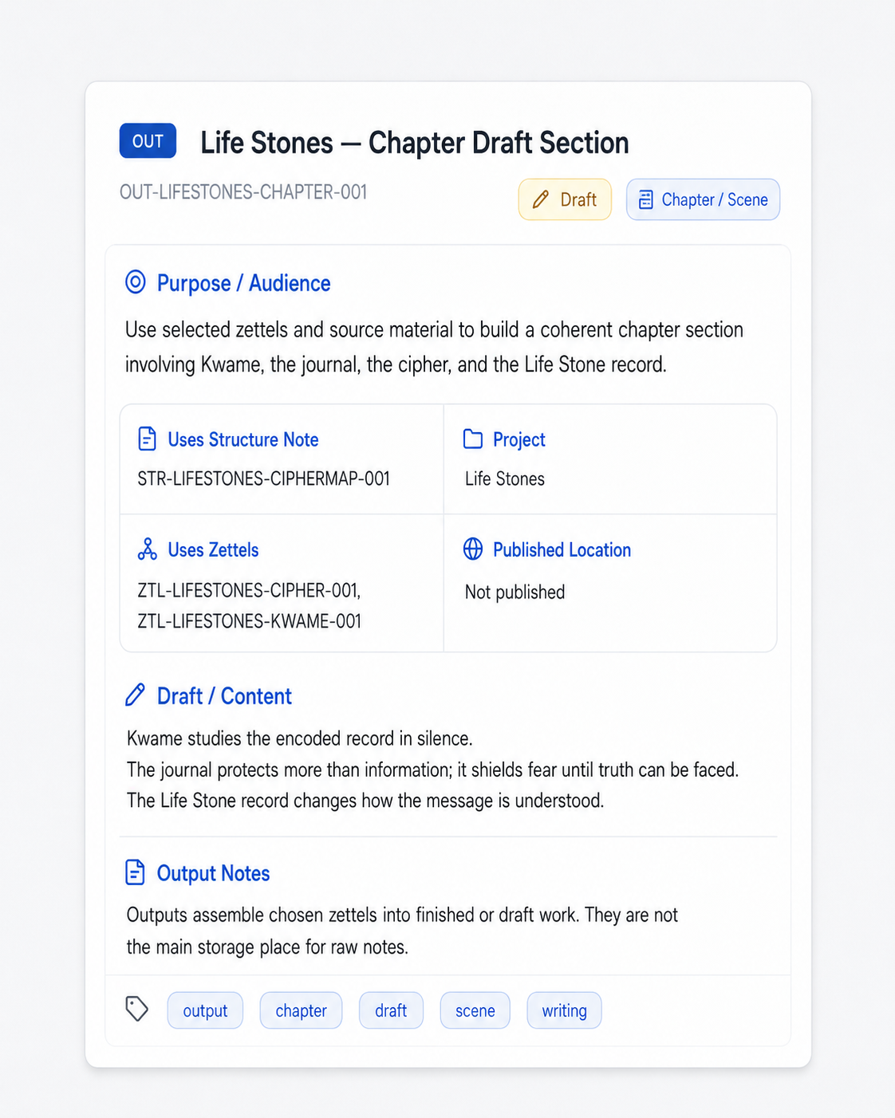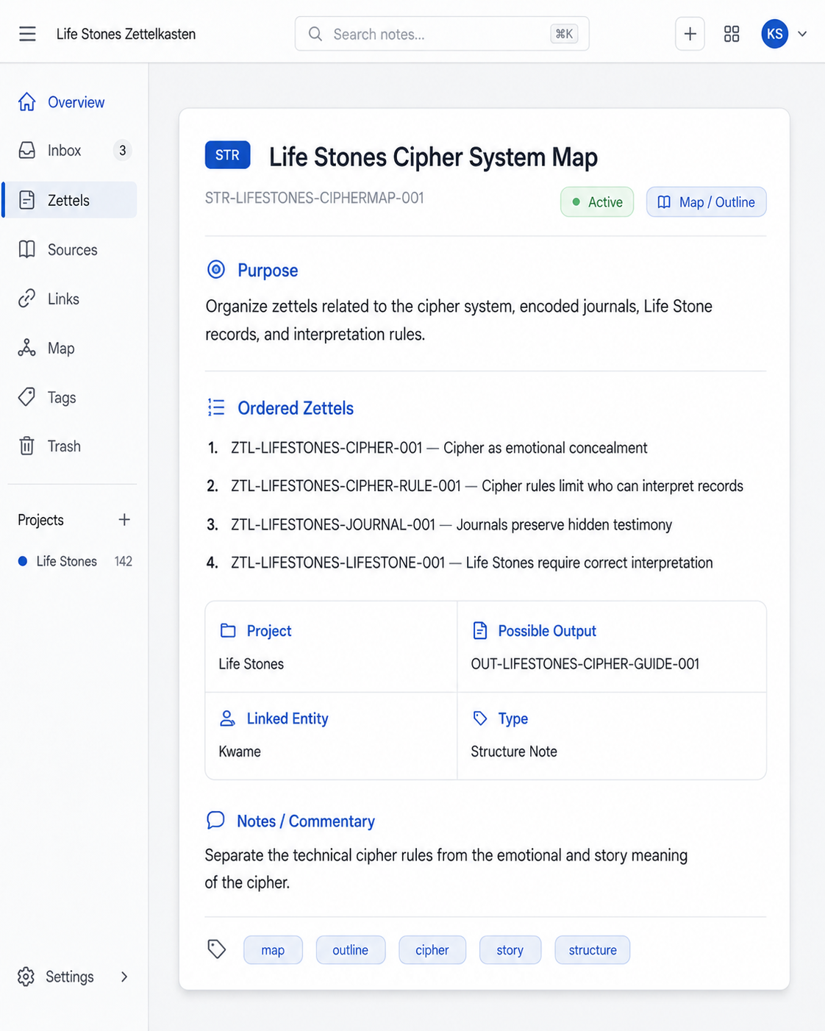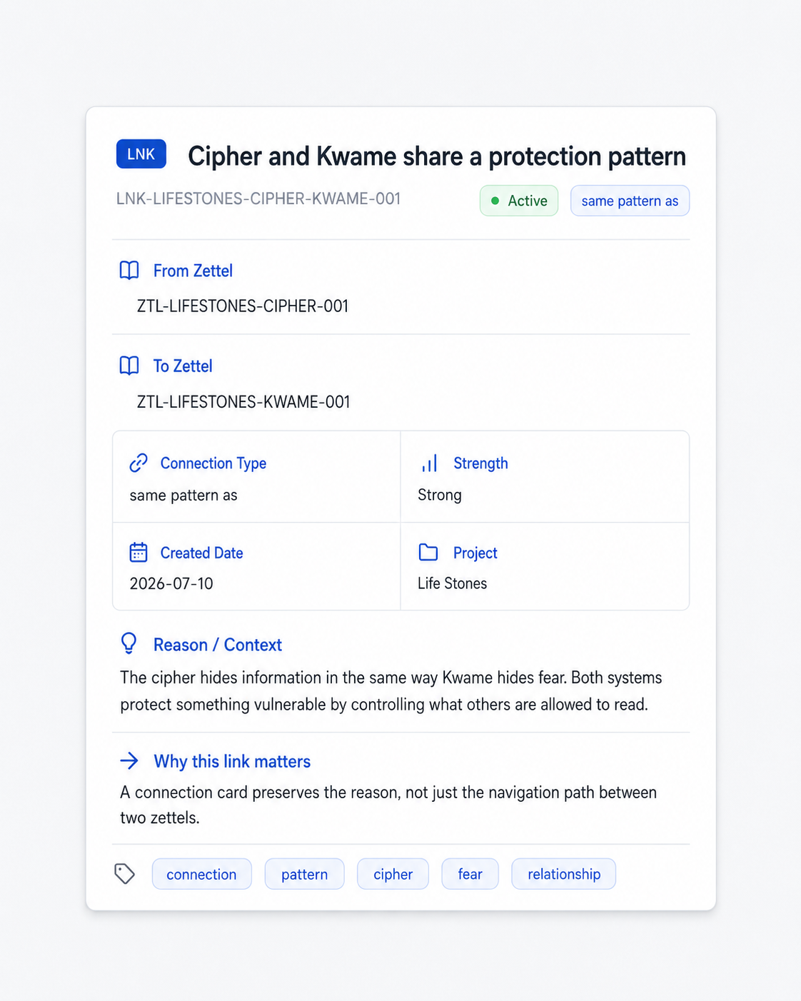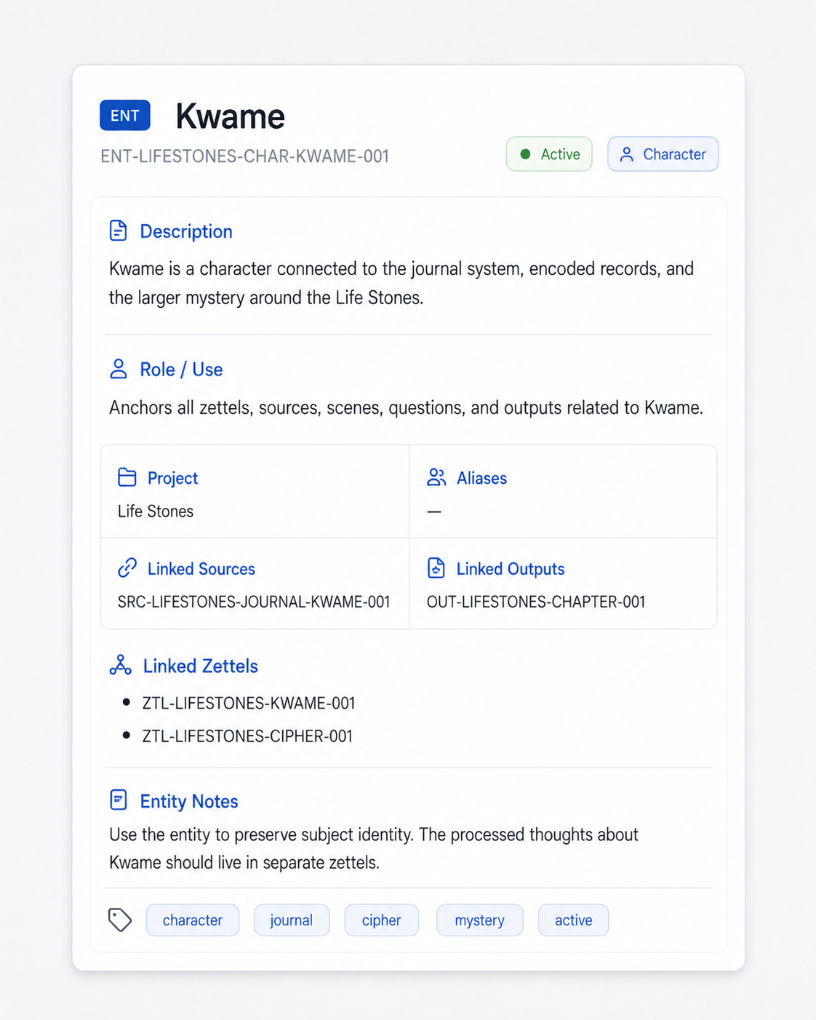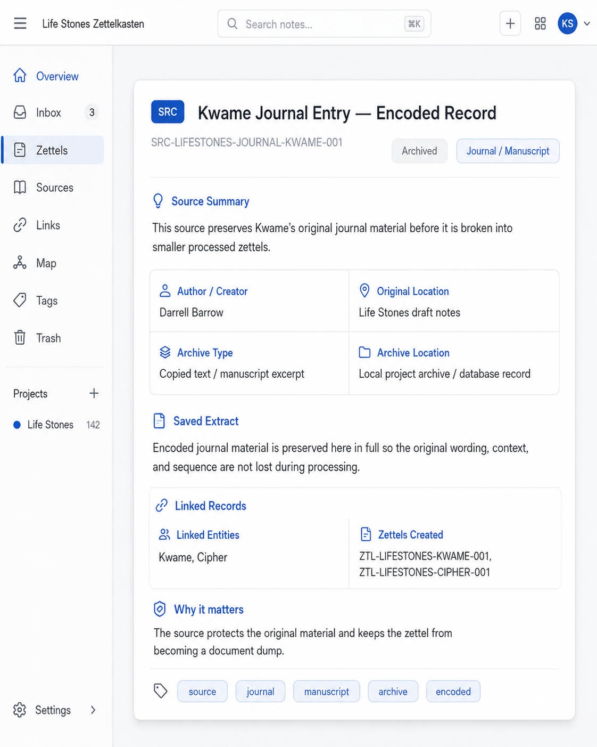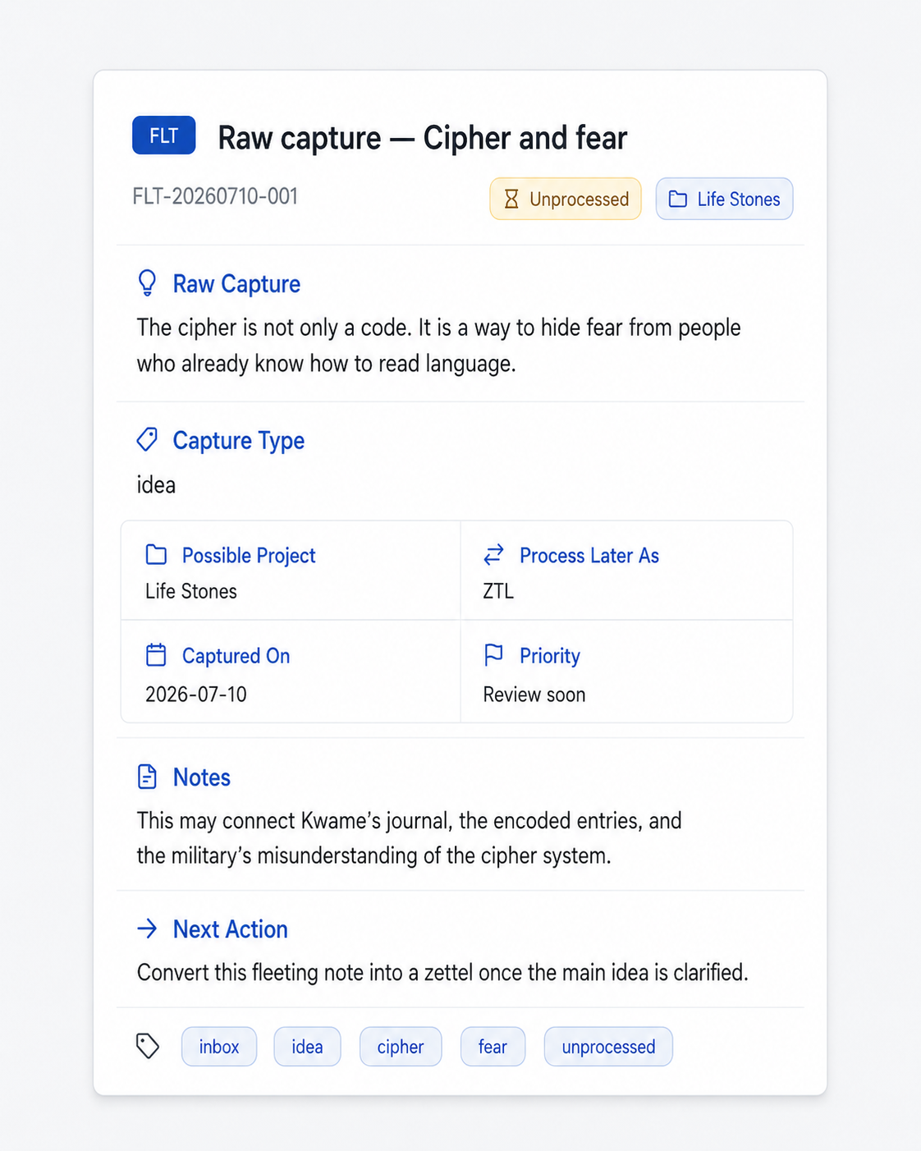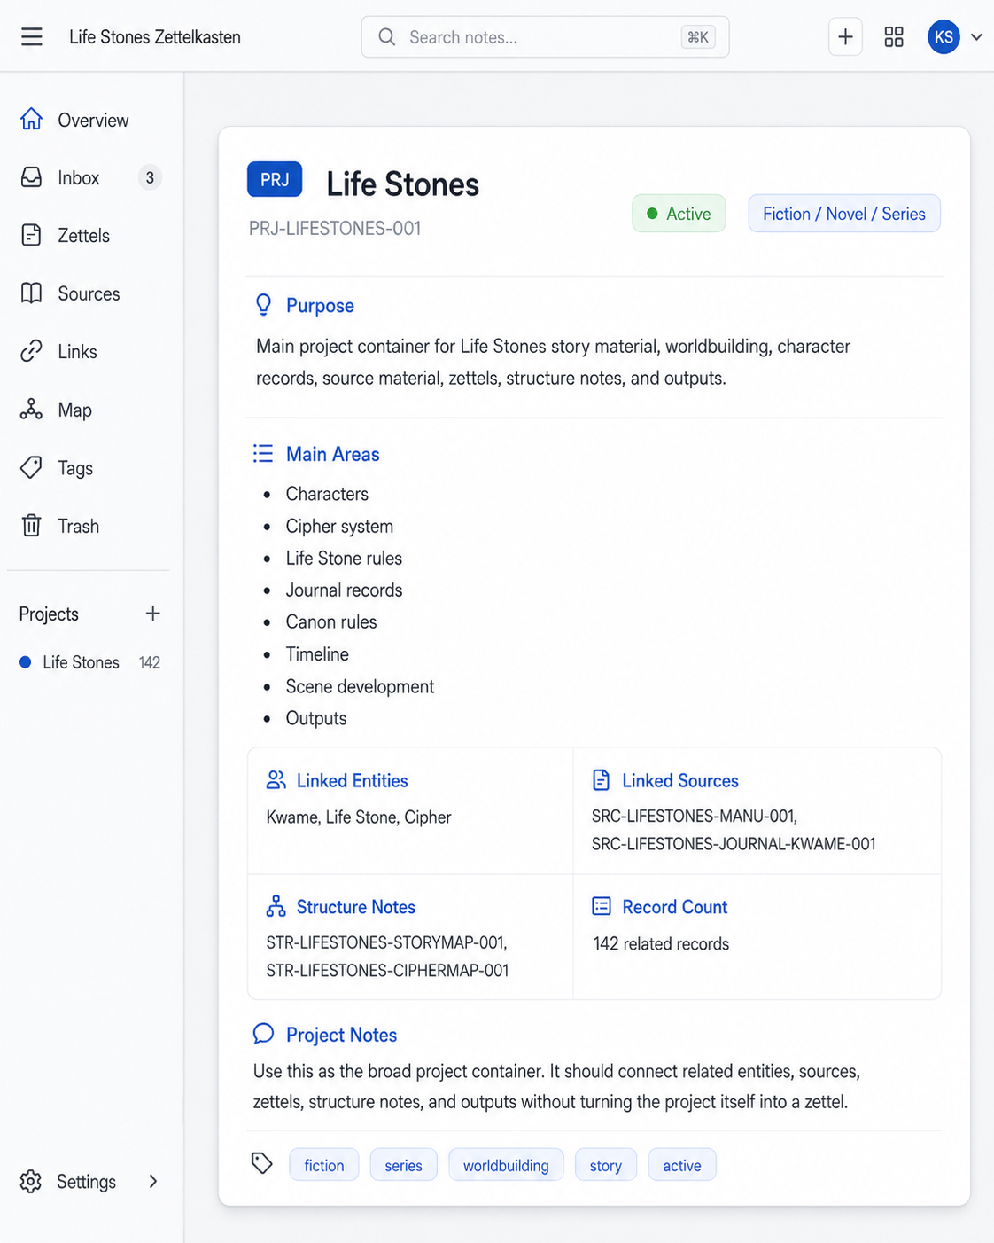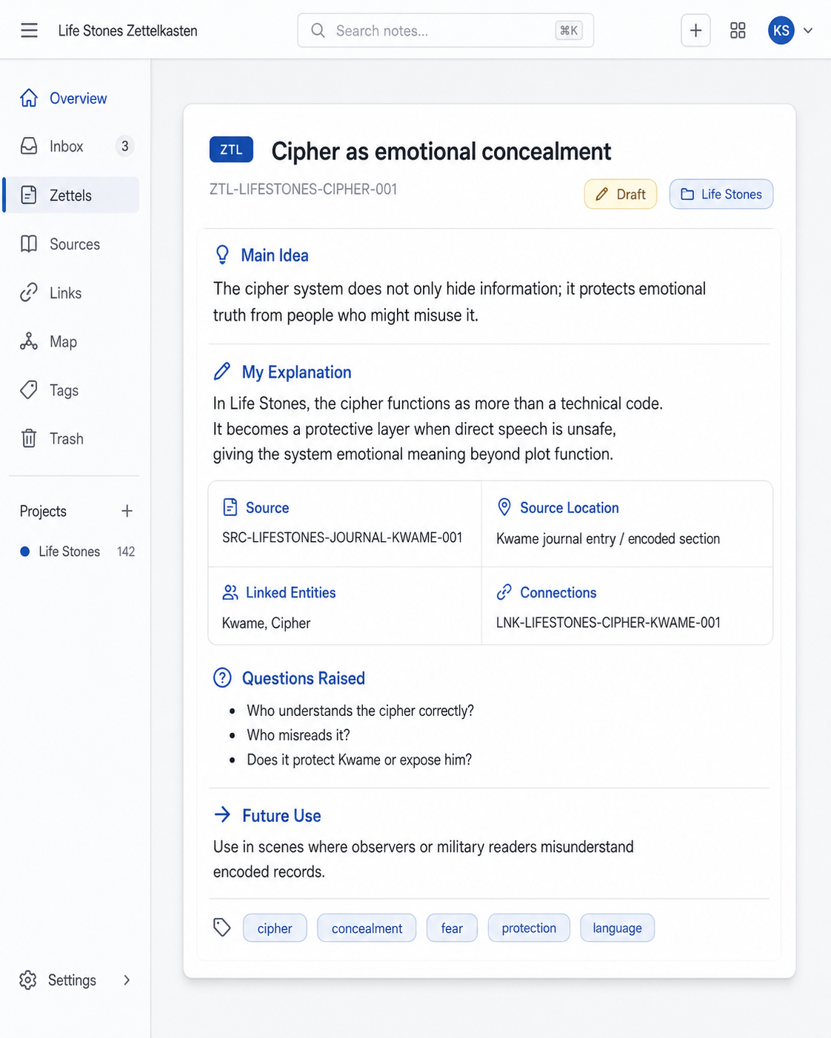 64

Part 1 — Core Operating System

Purpose and Boundary
The Antinet Zettelkasten is a digital-first personal knowledge system for Bible study, culinary work, blogging, essays, fiction, poetry, photography, technical notes, lexicons, ciphers, and general research. Its purpose is not to become a document store. Its purpose is to preserve sources, process ideas, connect thinking, arrange paths, and support finished work.
Boundary: This core guide defines the operating structure before finalizing screens, database models, and React components. Keep technical implementation in the application blueprint section.

Core Flow
Core rule
Source material -> Processed zettel -> Meaningful link -> Structure note -> Output

Digital Zettelkasten Core Setup

Source basis from Zettelkasten.de
The Zettelkasten.de introduction gives the core operating requirements this app needs to support: a Zettelkasten is a personal thinking and writing tool; it creates a web of thoughts instead of a collection of arbitrary notes; each zettel needs a unique identifier, a body/content area, and references; links need context; and structure notes act as maps through related zettels. This document translates those principles into an application setup.
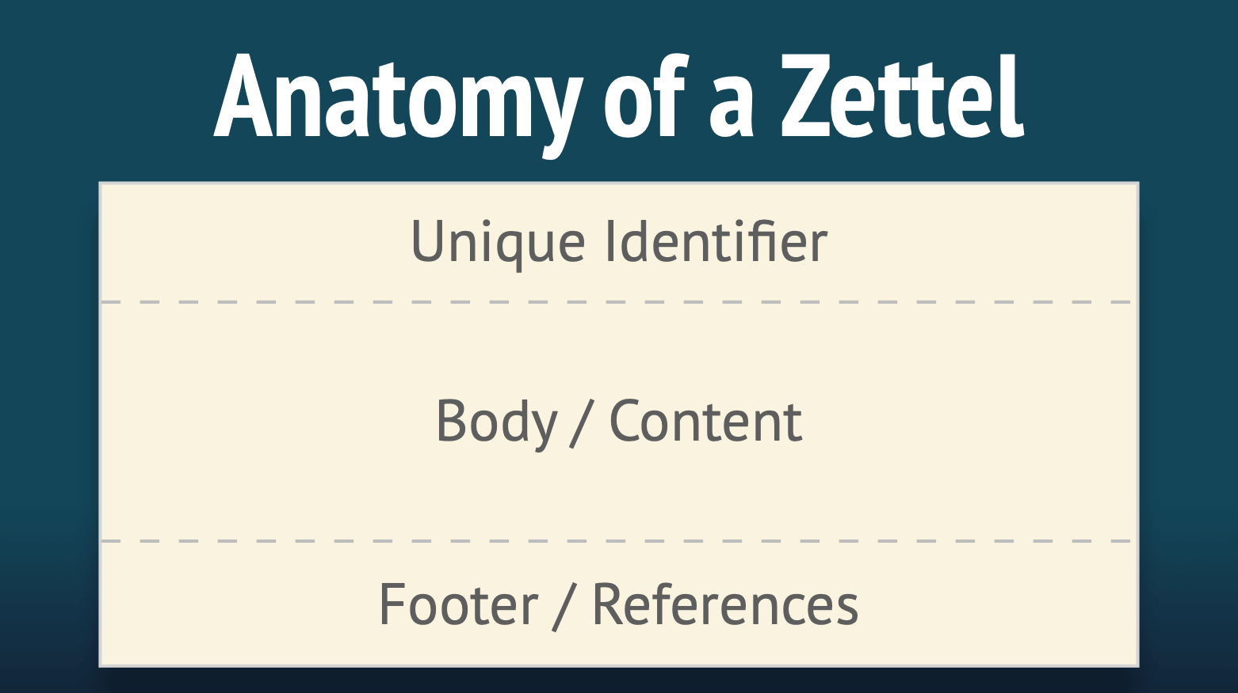
Figure 1. Core card anatomy: unique identifier, body/content, and footer/references. Source image: Zettelkasten.de Introduction.

Card section | Fields/content | Rule
Identity | Record ID, title, status | ID is permanent; title can change.
Thought | Main Idea, body | The main idea must state one thought before details are added.
Origin | Source, source location, citation/reference | Origin is preserved but does not control where the zettel lives.
Context | Project(s), entities, tags | A zettel can serve multiple projects.
Connections | Linked zettels, connection type, connection reason | No link without a reason.
Use | Future use, questions raised, output links | The note should be usable later.
SRC = preserve the original material -> extract one useful idea
ZTL = write the idea in your own words -> connect it to another zettel with a reason
LNK = store the relationship -> arrange related zettels in order
STR = create the path or outline -> write or assemble the final work
OUT = finished/draft output
Stage | What you do | Result
Fast capture | Save the seed without overthinking it. | FLT record.
Preserve | Save the source, copied text, PDF, screenshot, citation, and access date. | SRC record.
Process | Write one useful idea in your own words. | ZTL record.
Connect | Link zettels with relation and reason. | LNK record.
Arrange | Order related zettels for study, article, research, or writing. | STR record.
Create | Write the final post, lesson, recipe, poem, chapter, or essay. | OUT record.

1. The Core System: what must exist in the application
Main rule
Zettels are the app's center.
Sources feed zettels.
Connections explain relationships.
Structured notes create paths through the network.
Projects and tags organize without trapping notes in silos.
Outputs are built from selected zettels.

Core objects and their job
Object | Job in the system | What it must not become | Required app behavior
Source | Raw material: article, video, Bible passage, recipe, book, poem, photo, class note, code file, observation. | The zettel itself. | Can be linked to many zettels; shows which zettels it came from.
Zettel | One processed thought, insight, question, argument, definition, observation, rule, or creative unit. | A chapter dump, an article dump, a folder, or a document page. | Has a stable ID, title, main idea, body, references, and links.
Connection | A meaningful relationship between two zettels. | A blind backlink with no explanation. | Stores why the link exists and what kind of relationship it is.
Structure Note | A map or pathway through related zettels. | A folder that traps notes in one place. | Lists and orders zettels for a topic, argument, study, article, or project.
Project | A work context such as Bible Studies, The Zestful Gourmet, Poetry, Essays, React Apps, or a book. | The whole organization system. | A zettel can belong to more than one project.
Entity | Reusable person, concept, place, symbol, ingredient, technique, passage, character, tool, or theme. | A tag replacement. | Shows overlap across projects and sources.
Output | The thing created from zettels: blog post, Bible study, essay, recipe article, poem, chapter, menu, presentation, research summary. | The place where raw notes live. | Can collect chosen zettels and export or assemble them.
Tag | A quick filter or status marker. | The main relationship system. | Used lightly for status, workflow, or simple grouping.

2. Principle-to-application translation
Zettelkasten principle | What the app must do | Why this prevents restructuring
Unique address | Every zettel gets a permanent ID that never changes, even if the title changes. | Links stay stable.
Atomicity | The zettel form requires a Main Idea field before the body. | Notes stay thought-sized instead of becoming documents.
Personal thinking tool | The system is built around your own processed wording and use, not public categories. | Your app serves your thinking across domains.
Connection over collection | Creating a link requires a reason/context field. | Links remain useful months later.
References | Each zettel can point to a source, another zettel, or no source if it is your own thought. | You keep the origin without confusing source notes with processed notes.
Structure notes | Any topic can have an ordered map of zettels. | You avoid hard folders while staying organized.
Entry points | Search, entities, and structure notes serve as starting points. | You do not need huge folder trees.
Digital durability | Export and backup are part of the core setup. | Your knowledge is not trapped in one app or database.

3. The core zettel card layout
The zettel card in the app should be a thinking unit, not just a note form. It should preserve the Zettelkasten.de anatomy while adding digital fields that support searching, linking, reuse, and output.
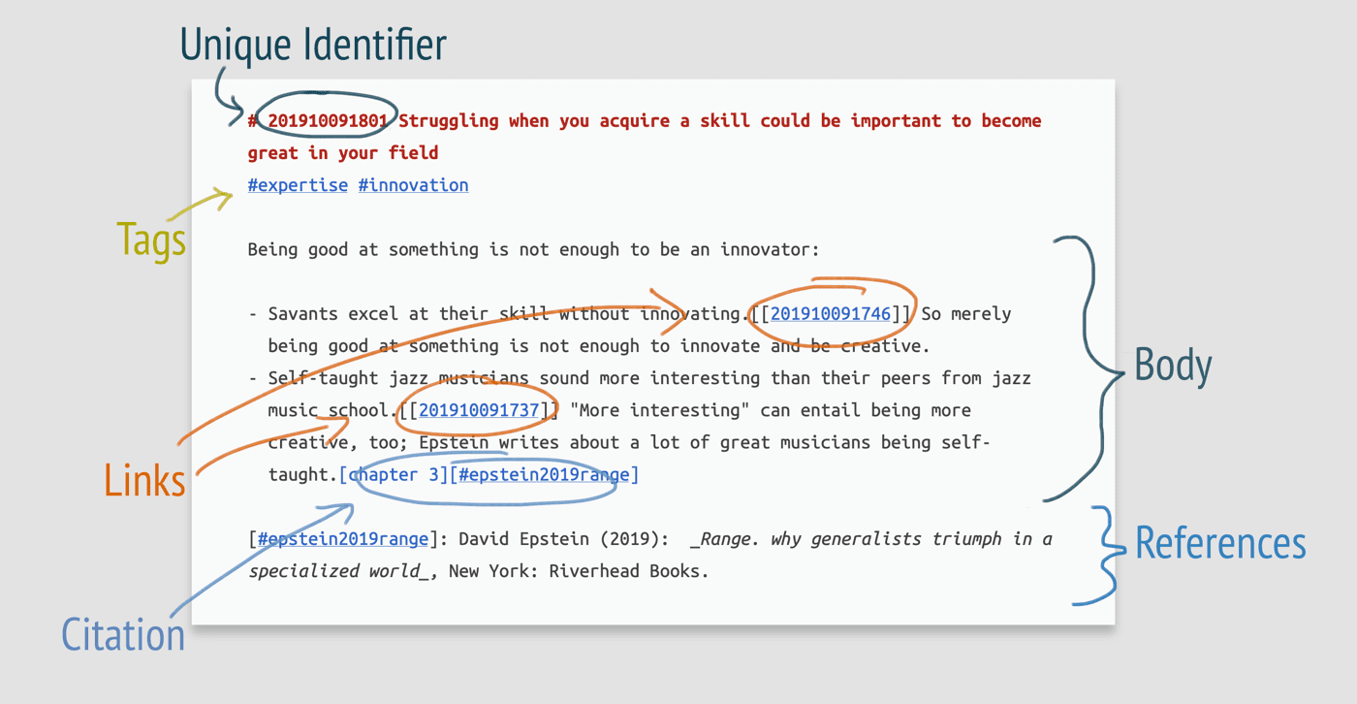
Figure 2. Full zettel example showing identifier, tags, links, body, citations, and references. Source image: Zettelkasten.de Introduction.

Required sections on the zettel screen
Section | Fields / content | Rule
Identity | Zettel ID, title, status | ID is permanent; title can change.
Thought | Main Idea, body | The main idea must state the single thought before adding details.
Origin | Source, source location, reference/citation | Origin is preserved but does not control where the zettel lives.
Context | Project(s), entities, tags | A zettel can serve multiple projects.
Connections | Linked zettels, connection type, connection reason | No link without a reason.
Use | Future use, questions raised, output links | The note should be usable later.
Maintenance | Created, updated, reviewed, archived | Review status should not change the note identity.

4. Connection setup
The connection screen is where the application becomes a Zettelkasten rather than a document store. A link needs a reason. That reason is created knowledge, because it tells the future user why the connection matters.

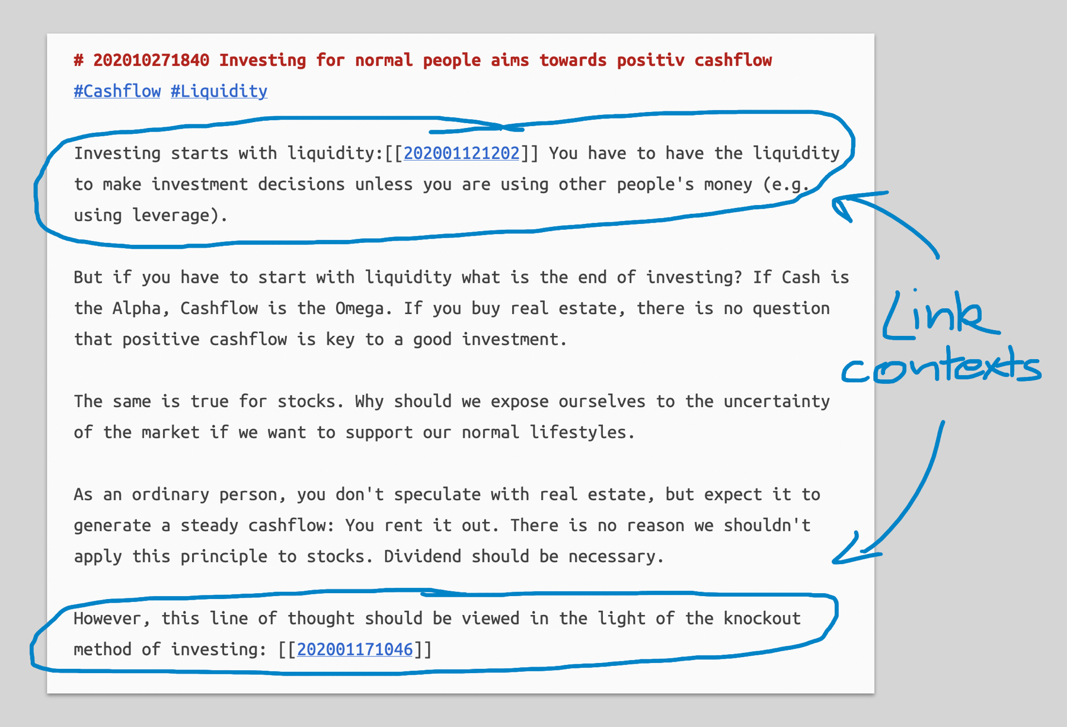
Figure 3. Link context example. The surrounding text explains why following the link matters. Source image: Zettelkasten.de Introduction
Connection rule for the app
The app should allow quick linking, but it should encourage or require a link reason.
A connection without a reason is only navigation. A connection with a reason becomes knowledge.
The connection reason should appear when viewing backlinks, so you know why the other note matters.
Connection type | Use it when... | Example
Supports | One zettel strengthens another. | Genesis 1:27 supports a note on human dignity.
Contrasts | Two notes disagree or create tension. | Hospitality as care contrasts with hospitality as performance.
Expands | One note develops another further. | Acid balance expands a sauce-building technique.
Example Of | One note is a concrete instance of another. | A poem using rain is an example of weather as emotional pressure.
Questions | One note raises a question about another. | A doctrine note raises a question about interpretation of a passage.
Applies To | A principle can be used in another context. | Mise en place applies to writing workflow.
Source For | A zettel feeds an output or another zettel. | A culinary research note feeds a blog article.
Similar To | A pattern repeats across domains. | Character concealment is similar to the practice of coded journaling.

5. Structure notes: the app’s map layer
A structure note is not a folder. It is a map of zettels. It can be a topic map, argument path, study outline, article outline, recipe development path, sermon/study map, or project map.

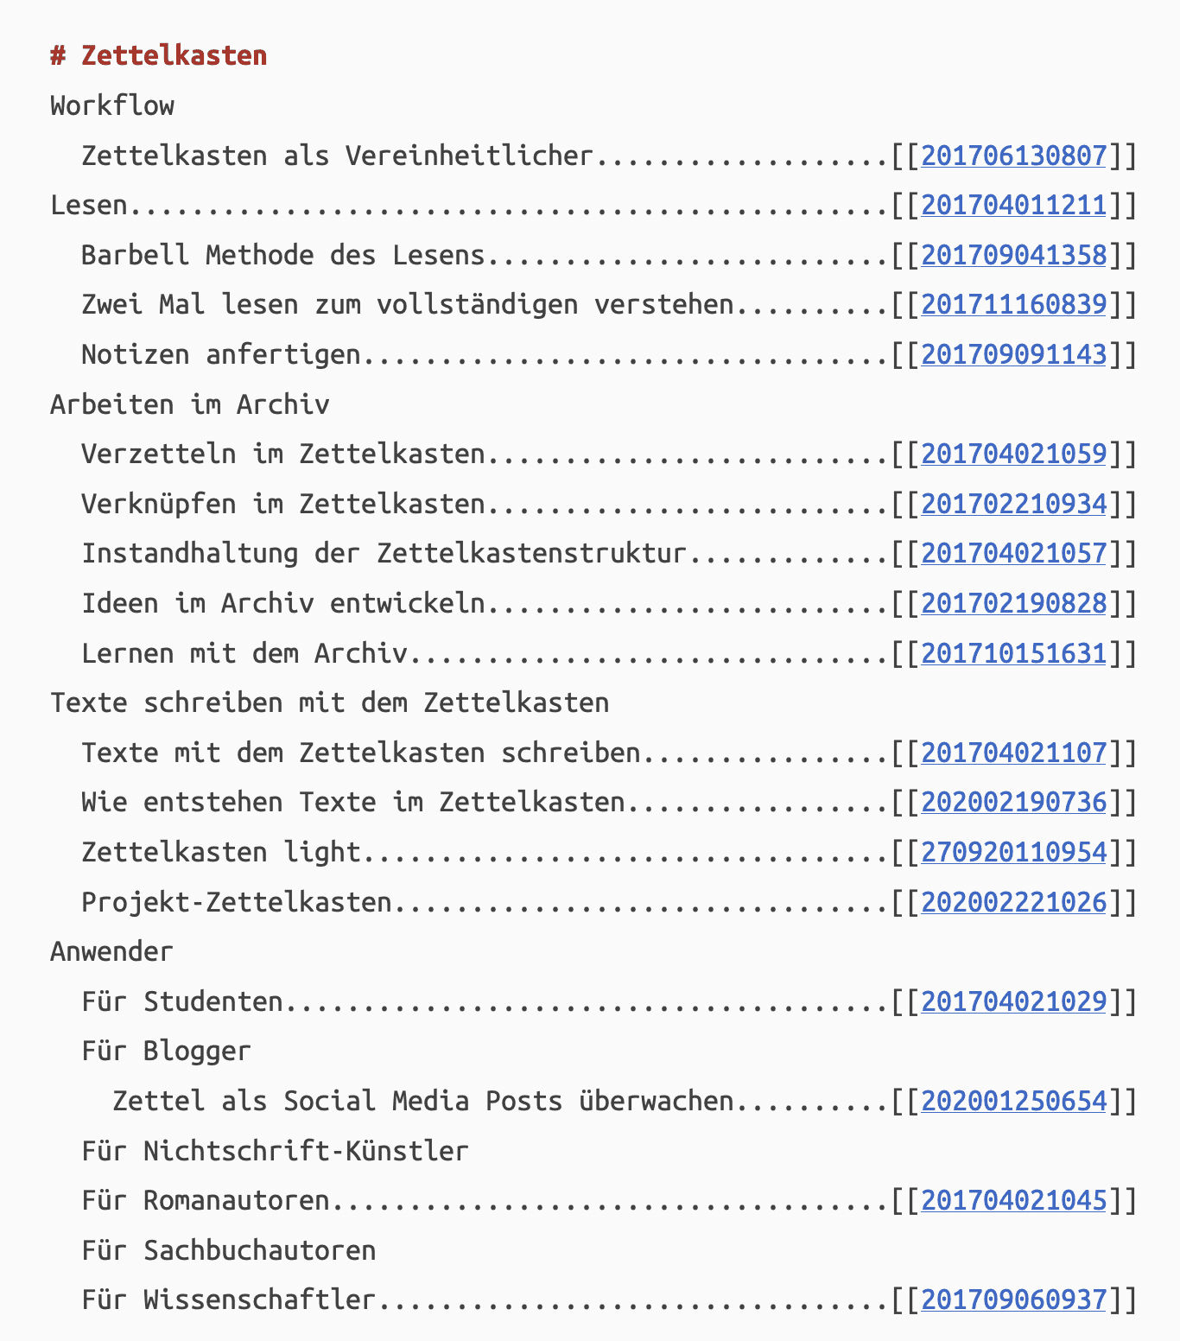
Figure 4. Structure note example: a table-of-contents-style map that links to zettels by ID. Source image: Zettelkasten.de Introduction.

Structure notes requirements
- A structure note has a title, purpose, topic, and ordered list of zettels.
- A zettel can appear in many structure notes.
- Structure notes can be hierarchical, sequential, comparative, or project-based.
- Structure notes are the closest digital replacement for the physical desk/sandbox used to arrange slips.
- A structure note should be able to become an outline for an output.
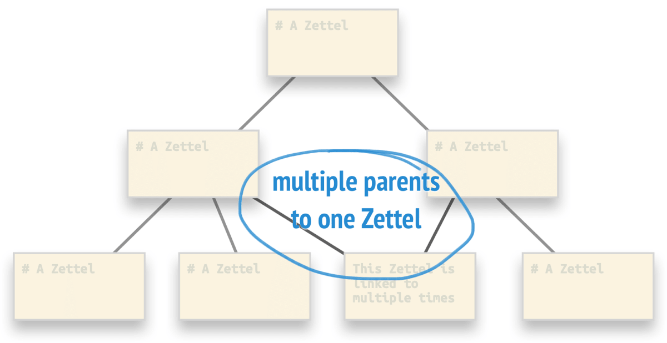
Figure 5. Semilattice/cross-connection idea: one zettel can belong to more than one path. Source image: Zettelkasten.de Introduction.

6. Entry points: how you find your way in
The app should not rely on a single, rigid folder hierarchy. Entry points should be flexible: search, structured notes, entities, projects, tags, sources, and outputs. Luhmann's register idea is useful here: an entry point is a place to start, not a full category system.
Entry point | Purpose | App behavior
Search | Find zettels by ID, title, body, entity, tag, source, or project. | Universal search bar should be available everywhere.
Structure Notes | Start from a curated map. | Show ordered zettel paths.
Entities | Find overlap across domains. | Click entity to see every connected zettel and project.
Projects | Work context. | Filter without trapping notes in one project.
Sources | Trace origin. | Show all zettels extracted from a source.
Outputs | Build finished work. | Collect zettels into draftable outputs.

7. Required workflow in the application
Core flow
1. Add or select a source.
2. Extract one useful thought.
3. Create a zettel with a permanent ID and clear main idea.
4. Attach source/reference if needed.
5. Add entities so overlaps become visible.
6. Link to related zettels with a reason.
7. Add to a structure note when it belongs to a path.
8. Use selected zettels in an output.

Screen behavior checklist
Screen | Must show | Must allow
Dashboard | Recent zettels, active structure notes, current outputs, review items. | Jump into search, create a new zettel, process sources, or do output work.
Sources | Source list and zettels created from each source. | Add raw material; process selected source into zettels.
Zettels | List/cards of atomic notes. | Filter, search, open, link, archive, add to structure note/output.
Zettel Detail | ID, main idea, body, source, entities, links, references, outputs. | Create connections with reasons.
Connections | Outgoing links, incoming links, connection reasons. | Edit link reason/type without changing either zettel.
Structure Notes | Maps, ordered paths, related zettels. | Reorder zettels, add commentary, build output from map.
Entities | Connect every zettel to a person, concept, ingredient, symbol, passage, tool, etc. | Spot overlap across Bible, culinary, writing, tech, and creative work.
Outputs | Drafts or planned works built from zettels. | Select, order, export, and revise output materials.

8. Domain-neutral zettel examples for the app
Bible study zettel
ID: 202607080701
Title: Image of God as human dignity
Main Idea: Genesis 1:27 frames human value as grounded in creation rather than in status or productivity.
Source: Genesis 1:27
Entities: image of God, dignity, creation, humanity
Connection reason example: Links to hospitality because care for people rests on valuing the person, not on usefulness.

Culinary zettel
ID: 202607080706
Title: Acid balances richness
Main Idea: Acid cuts richness by adding brightness and contrast, making heavy foods feel cleaner and more complete.
Source: kitchen practice / culinary training
Entities: acid, richness, sauce, balance, palate
Connection reason example: Links to recipe writing because explaining balance teaches the cook how to adjust, not just follow.

Blogging zettel
ID: 202607080711
Title: A recipe post should teach the decision, not only the steps
Main Idea: The strongest recipe writing explains why a choice is made so the reader can adapt the dish.
Source: personal writing practice
Entities: recipe writing, teaching, adaptation, reader trust
Connection reason example: Links to acid balance as a teaching decision point.

Creative overlap zettel
ID: 202607080716
Title: Concealment as protection
Main Idea: A person may hide the truth not to deceive others, but to survive long enough to understand what it means.
Source: writing observation
Entities: concealment, survival, truth, fear, identity
Connection reason example: Can link characters, poems, essays, and Bible study notes without making the system book-centered.

Photography/poetry zettel
ID: 202607080721
Title: Rain as emotional pressure
Main Idea: Rain can represent pressure building inside a person before grief finally breaks open.
Source: poem/photo observation
Entities: rain, grief, restraint, weather, pressure
Connection reason example: Links to poems, photos, fiction scenes, and essays where weather carries emotional meaning.

9. Rules that prevent rebuilding the app repeatedly
Rule | Reason
Do not organize the whole app by domain. | Bible, culinary, writing, fiction, tech, and photography are projects or source contexts, not separate zettelkastens.
Do not organize the whole app by source type. | A book, article, video, or recipe is raw material. The zettel is the processed thought.
Do not make tags do relationship work. | Tags filter. Links explain. Entities reveal overlap. Structure notes create paths.
Do not make folders the main structure. | Folders create silos. Structure notes provide maps without trapping zettels.
Do not allow links to be meaningless. | Require connection reason/context, or at least prompt for it.
Do not make a zettel depend on one project. | A strong zettel can be reused across projects.
Do not let sources and zettels merge. | Source notes preserve origin. Zettels preserve thought.
Do not make outputs the storage place. | Outputs assemble zettels; they do not replace the zettelkasten.

10. Final app blueprint
Build around these areas
Sources - raw material and origin tracking.
Zettels - permanent, atomic, processed thoughts.
Connections - meaningful links with reasons.
Structure Notes - maps, outlines, arguments, studies, topic paths.
Entities - reusable people, concepts, symbols, ingredients, passages, tools, places, and themes.
Projects - work contexts that can overlap.
Outputs - blog posts, studies, recipes, essays, poems, chapters, menus, articles, or other finished work.
Backups / Exports - durability so the system is not trapped or lost.
The fixed center: Zettel -> Connections -> Structure Notes. Everything else supports that center.

Sources used
- Zettelkasten.de. “Introduction to the Zettelkasten Method.” Used as a reference for the core principles of unique identifiers, zettel anatomy, references, link context, structuring notes, entry points, and software implementation requirements. URL: https://zettelkasten.de/introduction/
- Images in this document are from the same Zettelkasten.de introduction page and are included as visual reference examples for app planning.

Antinet Zettelkasten Master Core Guide
Top-down operating structure for a digital-first personal knowledge system
Purpose: consolidate the prior Zettelkasten planning notes into a single, clean guide without repeating material. This version defines the system from the top down: what each record is, how records move through the workflow, how to generate IDs, and how examples from your own work fit the structure.
Boundary: This is not a React code document and not a MongoDB model document. It is the core operating setup the application should follow before finalizing the data structure and screens.

Top-Down Map
Layer | Question it answers | Main records
1. Core rule | What is the overall workflow? | SRC -> ZTL -> LNK -> STR -> OUT
2. Record roles | What kind of thing is this? | Project, Source, Entity, Zettel, Connection, Structure Note, Output, Fleeting Note
3. ID system | How does the app consistently name it? | Record prefix + project/topic + subtype + subject + number
4. Workflows | How do I use it for real work? | Research, blogs, Scripture, culinary, poetry, fiction, photography
5. Migration | How do I fix my current app without starting over? | Rename, separate, move, split, connect, map
6. Templates | What fields should each record ask for? | Minimal forms for each record role

1. Core Four-Record Rule
Use this rule for every workflow
SRC = What the original material says
ZTL = What I understand from it
STR = How my zettels are arranged into a path
OUT = What I create from those arranged ideas
This rule works for Bible study, blogging, research, culinary work, writing, poetry, photography, technology notes, and book projects. It keeps preserved material separate from processed thinking.
Area | SRC | ZTL | STR | OUT
Scripture | Bible passage, translation note, commentary, sermon | Your understanding of one idea in the passage | Study path or topical outline | Bible study, teaching note, article
Blogging | Article, video, product page, observation | One useful idea from the source | Blog outline | Finished post
Research | PDF, web page, book, report, article | Insight, question, argument, or definition | Research map | Essay, report, study note
Culinary | Recipe, kitchen test, class note, ingredient research | Technique, principle, method, observation | Recipe or menu-development map | Recipe, menu, article, guide
Writing | Draft, outline, character profile, scene note | Story insight, pattern, theme, conflict | Plot, theme, or character map | Scene, chapter, book, poem
Photography | Photo, visual reference, location note | Visual idea, symbol, framing principle | Theme map | Photo essay, caption set, project statement

Record Roles: Do Not Call Everything a Note
The main correction is to identify the record's role before deciding where it belongs. This prevents the application from reverting to a document store.
Record Role | Job | Contains | Does not contain
PRJ - Project / Collection | Broad work area or container. | Between Realms, Aeroponics, Scriptures, Culinary Research, Poetry. | The full organization system or all the notes.
SRC - Archived Source | Preserves original material for offline access and citation. | Copied article text, PDF, screenshot, Bible passage, manuscript excerpt, recipe source, URL, access date. | Your final processed thought as the main note.
ENT - Entity | Holds a reusable subject identity. | Character, person, biblical figure, ingredient, place, concept, symbol, technique, tool, term. | A processed thought unless it is written as a zettel.
ZTL - Zettel | Holds one processed idea in your own words. | Main idea, explanation, source link, entities, future use, questions. | Full pasted articles, full profiles, whole manuscripts, broad topics.
LNK - Connection | Explains why two zettels relate. | From zettel, to zettel, relation type, reason/context. | Generic related links with no reason.
STR - Structure Note | Creates a path through related zettels. | Ordered zettels, purpose, notes, possible output. | Raw source archives or copied documents.
OUT - Output | Tracks the finished or draft work made from zettels. | Blog post, Bible study, essay, recipe, poem, chapter, menu, article. | Raw research dumps or saved pages.
FLT - Fleeting / Inbox | Captures raw ideas quickly before processing. | Phrase, image, question, seed, rough thought. | Final zettel logic or polished explanation.
Quick decision rule
If it preserves full copied material, it is SRC. If it identifies a subject, it is ENT. If it states one processed idea, it is ZTL. If it explains why two zettels relate, it is LNK. If it orders zettels into a path, it is STR. If it is something you create or publish, it is OUT. If it is raw capture, it is FLT.

Stage | What you do | Result
Fast capture | Save the seed without overthinking it. | FLT record.
Preserve | Save the source, copied text, PDF, screenshot, citation, access date. | SRC record.
Process | Write one useful idea in your own words. | ZTL record.
Connect | Link zettels with relation and reason. | LNK record.
Arrange | Order related zettels for study, article, research, or writing. | STR record.
Create | Write the final post, lesson, recipe, poem, chapter, or essay. | OUT record.

5. Connection Setup: The Link Needs a Reason
A connection without a reason is only navigation. A connection with a reason becomes knowledge because it explains to your future self why the other note matters.
Connection type | Use it when... | Example
supports | One zettel strengthens another. | Controlled misting supports water conservation research.
contrasts | Two notes differ or create tension. | Convenience in AeroGardens contrasts with DIY customization.
expands | One note develops another further. | Acid balance expands sauce-building technique.
example of | One note is a concrete instance of a broader idea. | Vegetable scrap stock is an example of sustainable food practice.
questions | One note raises an unresolved issue. | A Queen of Heaven passage raises a question about household worship.
applies to | A principle can be used in another context. | Mise en place applies to writing workflow.
same pattern as | Two notes share a pattern across domains. | Rain as emotional pressure connects poetry, photography, and fiction.

6. ID Prefix System and Automatic ID Generator
Your original ID logic already included project, type, subject, and sequence. The missing piece was the record role at the front. The app should generate IDs from dropdown choices to keep entry fast and efficient.
[RECORD]-[DOMAIN]-[PROJECT/TOPIC]-[SUBTYPE]-[SUBJECT]-[NUMBER]
Segment | How it should be chosen | Example
RECORD | Dropdown selected first. | SRC, ENT, ZTL, LNK, STR, OUT, PRJ, FLT
PROJECT/TOPIC | Dropdown from project/topic list. | BETREA, AERO, AEROGARDEN, QOH, CUL, SUSTAIN, POEM
SUBTYPE | Dropdown changes based on record type. | CHAR, WEB, BIBL, IDEA, QUES, BLOGMAP
SUBJECT | Optional short code when the subject needs clarity. | DARDUB, KIDTHO, RAIN, QOH
NUMBER | Generated by the app. | 001, 002, 003

Record Type | Prefix | Purpose
Project / Collection | PRJ | Work area or broad collection.
Archived Source | SRC | Saved original material.
Entity | ENT | Reusable subject identity.
Zettel | ZTL | Processed idea.
Connection | LNK | Reasoned relationship between zettels.
Structure Note | STR | Map/path through zettels.
Output | OUT | Finished or draft work.
Fleeting / Inbox | FLT | Quick raw capture.

Subtype list | Examples
Entity subtypes | CHAR, PERS, FIG, PLAC, CONC, SYMB, INGR, TECH, TERM, ORG
Source subtypes | WEB, ART, VID, BOOK, BIBL, RECIPE, MANU, PROF, PDF, OBS
Zettel subtypes | IDEA, QUES, THEM, DEF, ARG, METH, PRIN, SEED
Structure subtypes | STUDYMAP, BLOGMAP, CHARMAP, RESEARCHMAP, RECIPEMAP, THEMEMAP
Output subtypes | BLOG, STUDY, ARTICLE, ESSAY, RECIPE, POEM, CHAPTER, MENU, GUIDE

ID generator rule
You choose the meaning: record type, project/topic, subtype, and subject if needed. The application builds the final ID and assigns the next number.
Example:
Record Type: Entity -> ENT
Project: Between Realms -> BETREA
Subtype: Character -> CHAR
Subject Code: Darrell Dubquois -> DARDUB
Generated ID: ENT-BETREA-CHAR-DARDUB-001

7. Worked Examples Using Your Own Data

7.1 AeroGarden School Forum Blog Post
This example shows why you should not create a single zettel titled AeroGarden. The topic encompasses many smaller ideas that can connect to sustainability, culinary work, teaching, or a blog post.
Role | Example ID | Purpose
SRC | SRC-AEROGARDEN-WEB-001 | Save the product page, article, video notes, copied details, access date, and screenshots.
ENT | ENT-AEROGARDEN-PROD-001 | Identify AeroGarden as a reusable product/system entity.
ZTL | ZTL-AEROGARDEN-IDEA-001 | AeroGardens make hydroponics approachable for beginners.
ZTL | ZTL-AEROGARDEN-IDEA-002 | AeroGardens trade flexibility for convenience.
ZTL | ZTL-AEROGARDEN-IDEA-003 | AeroGardens helps you observe plant growth indoors.
STR | STR-AEROGARDEN-BLOGMAP-001 | Order selected zettels into the school forum post outline.
OUT | OUT-AEROGARDEN-BLOG-001 | Completed forum post written in prose.

7.2 Aeroponics and Sustainability Link
Record | Example
ZTL-AERO-IDEA-002 | Aeroponics can reduce water use through controlled misting.
ZTL-SUSTAIN-IDEA-001 | Water conservation matters in controlled food production.
LNK-AERO-SUSTAIN-001 | Relation: supports. Reason: controlled misting shows one way food production can reduce water waste compared with traditional soil irrigation.

7.3 Culinary Recipe and Sustainability
Role | Example ID | Purpose
SRC | SRC-CUL-RECIPE-001 | Original recipe, class note, kitchen test, or article.
ZTL | ZTL-CUL-SUSTAIN-001 | Using vegetable scraps for stock reduces waste and builds flavor.
ZTL | ZTL-SUSTAIN-IDEA-001 | Reducing waste is part of sustainable food practice.
LNK | LNK-CUL-SUSTAIN-001 | Relation: example of. Reason: vegetable scrap stock is a practical culinary example of reducing waste and extending ingredient usefulness.
STR | STR-CUL-SUSTAINMAP-001 | Arrange culinary sustainability zettels into an article, recipe guide, or teaching note.
OUT | OUT-CUL-ARTICLE-001 | Finished article, recipe note, or menu-development guide.

7.4 Bible Study: Queen of Heaven
The Scripture itself is a source. Your understanding of the passage is a zettel. The study path is a structure note. The completed Bible study is an output.
Role | Example ID | Purpose
PRJ | PRJ-QOH-001 | Queen of Heaven topical study.
SRC | SRC-QOH-BIBL-001 | Jeremiah 7:18 passage, translation, citation, notes.
SRC | SRC-QOH-BIBL-002 | Jeremiah 44:17-19 passage, translation, citation, notes.
ENT | ENT-QOH-CONC-001 | Queen of Heaven as a concept/title/deity reference.
ZTL | ZTL-QOH-IDEA-001 | The Queen of Heaven passages show idolatry as household practice.
ZTL | ZTL-QOH-IDEA-002 | Jeremiah confronts worship that competes with covenant loyalty.
STR | STR-QOH-STUDYMAP-001 | Ordered study path through the zettels.
OUT | OUT-QOH-STUDY-001 | Completed Bible study, lesson, or article.

7.5 Poetry: Phrase, Image, and Finished Poem
Stage | Example ID | Purpose
FLT | FLT-20260708-001 | Raw phrase: the house knows before I do.
ZTL | ZTL-POEM-SEED-001 | Domestic space can sense grief before the speaker admits it.
ZTL | ZTL-POEM-IMAGE-RAIN-001 | Rain can represent pressure before emotional release.
LNK | LNK-POEM-GRIEF-001 | Relation: example of. Reason: the line shows grief being managed through physical action instead of speech.
STR | STR-POEM-RAIN-001 | Arrange images and emotional movement for the poem.
OUT | OUT-POEM-RAIN-001 | Finished poem.

7.6 Between Realms: Character Profile vs Entity vs Zettel
Darrell Dubquois is not a zettel on his own. He is an entity/character record. A zettel is a single processed idea about him.
Current record | Correct role | Better ID | Reason
Between Realms overview | Project, Source, or Output depending on use | PRJ-BETREA-001 or SRC-BETREA-MANU-001 or OUT-BETREA-DRAFT-001 | The overview is not one processed idea.
Darrell Dubquois card | Entity / Character | ENT-BETREA-CHAR-DARDUB-001 | It identifies the subject and anchors all related material.
Full Darrell profile | Archived Source or Entity profile | SRC-BETREA-PROF-DARDUB-001 | It preserves full profile information.
Insight about Darrell | Zettel | ZTL-BETREA-DARDUB-001 | One reusable thought about the character.

Zettel ID | Title | Main Idea
ZTL-BETREA-DARDUB-001 | Darrell Dubquois hides conflict behind restraint | Darrell’s outward calm masks unresolved internal tension.
ZTL-BETREA-DARDUB-002 | Darrell Dubquois mirrors the divided-world theme | Darrell’s identity reflects the larger split between realms, loyalty, and belonging.
ZTL-BETREA-DARDUB-003 | Darrell overlaps with characters who carry hidden burdens | Darrell belongs to a recurring pattern in your work: characters who appear controlled while carrying private pressure.

Book and Fiction Workflow Layer: Turning Your Books Into a Zettelkasten
A practical note system for breaking down finished books, drafts, and new story ideas.
Purpose: This section explains how to turn a book into connected Zettelkasten records without reducing it to random chapter summaries. The goal is to build a living system for revision, sequels, canon tracking, worldbuilding, poetry collections, nonfiction projects, and new books.
Core rule: Do not turn every page into a note. Instead, turn important ideas, events, characters, rules, questions, and patterns into linked records.

1. Start With a Source Note
The book itself becomes the source. Every smaller record can link back to this source record, so the app always preserves the idea's origin.
SOURCE: Emperor's Earth
Author: Darrell Pender / Darrell Barrow
Version: Revision 15
Type: Science fiction novel/series canon
Main focus: Kido, Mirrians, Earth destruction, power, peace, control, identity
Use this for other books too: one source record per manuscript, poetry collection, cookbook, nonfiction project, or story universe.

2. Use Fiction-Friendly Note Types
A fiction Zettelkasten needs more than regular idea notes. Use note types that match how stories are built.
Note Type | Purpose
Character Note | Tracks who the person is, what they want, wounds, motives, relationships, powers, contradictions, and growth.
Event Note | Captures a major plot event and its consequences.
Theme Note | Tracks repeated meaning such as peace, control, trauma, responsibility, power, forgiveness, faith, grief, or identity.
Worldbuilding Note | Stores rules for places, cultures, technology, languages, governments, powers, food, rituals, and history.
Timeline Note | Places events in order so cause and effect stay clear.
Canon Rule Note | Protects rules that must stay consistent across books.
Question Note | Holds unresolved problems, mysteries, contradictions, and future research.
Book-to-Book Link Note | Connects one book, series, character arc, or theme to another.

3. Build a Simple ID System
Use short prefixes so notes from different books and universes do not get mixed together.
EE = Emperors Earth
LS = Life Stones
TZG = The Zestful Gourmet
POEM = Poetry
Examples:
EE-KIDO-001
EE-FELDMAN-001
EE-MIRRIA-001
LS-KWAME-001
S-MERCER-001
POEM-RAIN-001

4. Create Hub Notes First
Hub notes are index pages. They help you move through the project without rereading the whole manuscript every time.
EE-HUB-BOOK
EE-HUB-CHARACTERS
EE-HUB-TIMELINE
EE-HUB-THEMES
EE-HUB-WORLDBUILDING
EE-HUB-POWER-SYSTEM
EE-HUB-UNRESOLVED-QUESTIONS
EE-HUB-BOOK-2-SEEDS
Example hub note:
ID: EE-HUB-THEMES
Title: Emperor's Earth - Theme Map
Themes:
- Peace versus control
- Survival after collapse
- Trauma and power
- Chosen one versus dangerous weapon
- Friendship as salvation
- Forgiveness and responsibility
- Humanity's hidden darkness
Linked notes:
- EE-THEME-PEACE-001
- EE-THEME-CONTROL-001
- EE-THEME-TRAUMA-001
- EE-THEME-RESPONSIBILITY-001

5. Turn Chapters Into Event Cards, Not Summaries
Do not make one giant note for a chapter. Break the chapter into major events, turning points, reveals, and consequences.
EE-EVENT-KIDO-BACKSTORY-001
EE-EVENT-JA-JOREL-WARNING-001
EE-EVENT-MIRRIAN-ATTACK-001
EE-EVENT-KIDO-FIRST-POWER-001
EE-EVENT-RICKY-PRISON-BREAK-001
EE-EVENT-HOUSE-TRANSFORMATION-001
EE-EVENT-COMMAND-CENTER-001
Every event note should answer:
- What happened?
- Who changed?
- What rule, theme, or relationship was revealed?
- What future consequence does this create?
- What notes should this connect to?

6. Example Notes From Emperors Earth

Character Note Example
ID: EE-KIDO-001
Title: Kido Thompson
Type: Character
Book: Emperors Earth
Core idea:
Kido is a wounded survivor whose search for peace becomes complicated by immense destructive power.
Important traits:
- Shaped by childhood rejection and abuse
- Finds identity through music
- Deep need for peace and belonging
- Power awakens after the Mirrian attack
- Can become salvation or destruction
Links:
- EE-THEME-PEACE-001
- EE-THEME-POWER-001
- EE-EVENT-MIRRIAN-ATTACK-001
- EE-XAVIER-001

Theme Note Example
ID: EE-THEME-PEACE-001
Title: Peace versus No Peace
Type: Theme
Book: Emperor's Earth
Core idea:
Peace is not only political. It is emotional, spiritual, relational, and planetary.
Evidence:
- Ja-Jorel is connected to peace.
- Na-Ja-Jorel means no peace.
- Kido seeks inner peace while the world collapses.
- Feldman seeks control instead of peace.
Questions:
- Is Kido's power guided by peace or trauma?
- Can peace survive after betrayal?
- Does Kido restore peace or enforce order?
Links:
- EE-KIDO-001
- EE-JA-JOREL-001
- EE-FELDMAN-001
- EE-EVENT-NO-PEACE-001

Canon Rule Note Example
ID: EE-CANON-MIRRIAN-001
Title: Mirrian Language Rule: Ja-Jorel / Na-Ja-Jorel
Type: Canon Rule
Book: Emperor's Earth
Rule:
Ja-Jorel is connected to peace. Na-Ja-Jorel means no peace.
Use:
Keep this consistent across all future books, dialogue, prophecy, and Mirrian cultural references.
Links:
- EE-THEME-PEACE-001
- EE-WORLD-MIRRIA-001
- EE-JA-JOREL-001

7. Practical Workflow for Finished Books
- Create one source note for the book.
- Create hub notes for characters, timeline, themes, worldbuilding, and unresolved questions.
- Create character notes from the character profile section or cast list.
- Create event notes from the table of contents and chapter turning points.
- Create theme notes when the same meaning appears across chapters.
- Create canon rule notes for powers, language, culture, locations, technology, and history.
- Create question notes for contradictions, unclear motives, missing transitions, or sequel seeds.
- Link everything back to the correct hub notes.

8. Practical Workflow for New Books
- Start with a source note for the new project before drafting.
- Create a book hub, character hub, theme hub, and worldbuilding hub.
- Add only the notes you truly need at first: protagonist, antagonist, central conflict, setting, and core theme.
- During drafting, create event notes only for major turns, reveals, losses, decisions, and consequences.
- Use question notes instead of forcing answers too early.
- After each chapter, add only the notes needed to protect continuity and future development.
- Before revision, review hubs and questions to see what needs strengthening.

9. Suggested Fields for Your Zettelkasten App
Title
Book / Project
Note Type
Characters
Location
Timeline Position
Canon Status
Summary
Main Idea
Links
Questions Raised
Future Use
Tags
Suggested note type values:
Character
Event
Theme
Worldbuilding
Timeline
Canon Rule
Quote
Question
Scene Seed
Book Connection
Revision Note

10. Strong First Pass for Emperors Earth
Start with these notes before breaking down the entire manuscript:
EE-HUB-BOOK
EE-HUB-CHARACTERS
EE-HUB-TIMELINE
EE-HUB-THEMES
EE-HUB-WORLDBUILDING
EE-KIDO-001
EE-FELDMAN-001
EE-RICKY-001
EE-MIRRIA-001
EE-THEME-PEACE-001
EE-THEME-CONTROL-001
EE-EVENT-MIRRIAN-ATTACK-001
EE-EVENT-KIDO-FIRST-POWER-001

11. Blank Templates

Character Note Template
ID:
Title:
Type: Character
Book / Project:
Core idea:
Role in story:
Wound / fear:
Desire/goal:
Contradiction:
Relationships:
Changes over time:
Canon details:
Questions:
Links:

Event Note Template
ID:
Title:
Type: Event
Book / Project:
Chapter / Section:
Timeline Position:
What happened:
Characters involved:
What changed:
Consequences:
Themes revealed:
Canon rules affected:
Questions raised:
Links:

Theme Note Template
ID:
Title:
Type: Theme
Book / Project:
Core idea:
Where it appears:
Characters connected to it:
Scenes or events connected to it:
What the book seems to say about it:
Questions:
Links:

Canon Rule Note Template
ID:
Title:
Type: Canon Rule
Book / Project:
Rule:
Where established:
What it affects:
Exceptions or limits:
Do not contradict:
Future use:
Links:

12. Book-Specific Item Types and Storage Rule
Group | Values
Book and Fiction Types | character, event, theme, worldbuilding, timeline, canon-rule, question, scene-seed, book-connection, quote
Lexicon Types | lexicon-entry, lexicon-language, lexicon-rule, term-history, pronunciation-note, symbol-note
Cipher and Journal Types | cipher-system, cipher-rule, cipher-key, cipher-record, cipher-ledger, journal-entry, encoded-journal-entry, journal-artifact
Code Tool Types | code-tool, code-snippet, code-file, code-run, code-dependency, code-note
Keep book-specific features within the general note system by using noteType values. Do not create a separate model for each special feature.
Book-Specific Item | Stored As
Lexicon entry | noteModel.js with noteType = lexicon-entry
Cipher system | noteModel.js with noteType = cipher-system
Cipher rule | noteModel.js with noteType = cipher-rule
Cipher record | noteModel.js with noteType = cipher-record
Python code tool | noteModel.js with noteType = code-tool
Kwame journal entry | noteModel.js with noteType = journal-entry
Encoded journal | noteModel.js with noteType = encoded-journal-entry
Canon rule | noteModel.js with noteType = canon-rule
Hub page | noteModel.js with noteType = structure or index

13. Example Life Stones Zettel IDs
LS-HUB-CIPHER
LS-CIPHER-SYSTEM-001
LS-CIPHER-RULE-001
LS-CIPHER-RECORD-001
LS-CODE-CIPHER-GENERATOR-001
LS-JOURNAL-KWAME-001
LS-JOURNAL-ENCODED-001
LS-CANON-CIPHER-001
LS-LEX-STONE-ONYX-001
LS-LEX-ALCHEMIST-001

8. Application Areas and Screen Labels
You can correct the current app without starting over by reassigning each section's role. The labels matter because they train the workflow.
Current/possible label | Correct role | What belongs there
Notebooks | Projects / Collections | Broad work areas like Scriptures, Poetry, Aeroponics, Between Realms, Culinary Research.
References | Archived Sources | URLs, copied material, access dates, PDFs, screenshots, source summaries.
Notes | Zettels | Only processed thoughts, questions, insights, principles, arguments, definitions, or creative units.
Links | Connections | From zettel, to zettel, relation type, reason/context.
New section | Entities | Characters, biblical figures, ingredients, places, symbols, concepts, tools, terms.
New section | Structure Notes | Maps/outlines/order through zettels.
New section | Outputs | Finished or draft blog posts, studies, recipes, poems, chapters, articles.
New section | Inbox / Fleeting | Quick raw captures waiting to be processed.

Current app diagnosis
The app is not wrong; it is too broad under Notes. It should stop treating projects, sources, entities, outputs, and zettels as the same record type.

9. Migration Plan for Existing Records
Step | Action | Result
1 | Add Record Type to each existing item. | You can identify whether it is PRJ, SRC, ENT, ZTL, STR, OUT, LNK, or FLT.
2 | Rename broad Notebooks to Projects / Collections. | They become work areas, not the knowledge center.
3 | Move full pasted pages, articles, profiles, manuscripts, and screenshots into Archived Sources. | Preserves material without turning it into zettels.
4 | Move characters, ingredients, concepts, biblical figures, symbols, and recurring subjects into Entities. | Creates overlap across projects.
5 | Split large topic notes into one-thought zettels. | Each zettel can travel to other projects.
6 | Replace weak related links with relation + reason. | Connections become meaningful.
7 | Create structure notes for active outputs. | Zettels become usable paths.
8 | Create output records for finished or draft works. | The final work is separate from the zettel network.

10. Minimal Templates

10.1 Fleeting / Inbox Template
ID:
Raw Capture:
Capture Type: phrase | image | question | idea | research lead | scene spark | recipe idea
Possible Project:
Process Later As: SRC | ZTL | ENT | STR | OUT
Notes:

10.2 Archived Source Template
ID:
Title:
Source Type:
Author / Creator:
Website / Publisher:
Original URL / File Path:
Access Date:
Archive Type:
Archive Location:
Copied Text / Saved Extract:
Source Summary:
Linked Entities:
Linked Zettels:

10.3 Entity Template
ID:
Name:
Entity Type:
Aliases:
Project(s):
Description:
Role / Use:
Linked Sources:
Linked Zettels:
Linked Outputs:
Tags:

10.4 Zettel Template
ID:
Title:
Main Idea:
My Explanation:
Source:
Source Location:
Linked Entities:
Connections:
Questions Raised:
Future Use:
Status:
Tags:

10.5 Connection Template
ID:
From Zettel:
To Zettel:
Connection Type:
Reason / Context:
Strength:
Created Date:

10.6 Structure Note Template
ID:
Title:
Purpose:
Project(s):
Ordered Zettels:
Notes / Commentary:
Possible Output:
Status:

10.7 Output Template
ID:
Title:
Output Type:
Purpose / Audience:
Uses Structure Note:
Uses Zettels:
Draft / Content:
Status:
Published Location:

11. Final Checks Before Creating a Record
Question | If yes, create...
Am I preserving what someone else said or what a source contained? | SRC
Am I identifying a person, character, place, ingredient, concept, symbol, biblical figure, or tool? | ENT
Am I writing one clear thought in my own words? | ZTL
Am I explaining why two zettels relate? | LNK
Am I arranging zettels into an outline or pathway? | STR
Am I making the final blog post, study, recipe, poem, chapter, essay, or article? | OUT
Am I quickly capturing something before I lose it? | FLT
Core sentence
The source protects the material. The entity protects the subject identity. The zettel protects the thinking. The connection protects the relationship. The structure note protects the path. The output protects the finished work.

Archived Source to Zettel Core Setup
A practical separation guide for the Antinet Zettelkasten app
Purpose of this document
This document only covers the missing separation that caused the system to drift into a document store: the distinction between Archived Source and Zettel. It does not repeat the broader Zettelkasten explanation, the book-to-zettel guide, the React structure, or the database model details.

1. The Core Separation
Record | Job | Contains | Does Not Contain
Archived Source | Preserves the outside material for offline access and citation. | Copied article text, PDF/screenshot reference, URL, access date, citation, source summary. | Your final processed thought as the main note.
Zettel | Stores one processed idea in your own words. | Main idea, explanation, source link, connections, future use. | Full pasted articles, whole web pages, long copied passages.
Connection | Explains why two zettels belong together. | From zettel, to zettel, relationship type, reason/context. | Generic “related” links with no reason.
Structure Note | Creates a path through related zettels. | Ordered zettels, purpose, notes, possible output. | Raw source archives or copied documents.
Output | Tracks what you make from zettels. | Blog post, Bible study, article, essay, poem, recipe article, chapter, teaching note. | Raw research dumps.

Simple rule
Archived Source = “What did the source say?”
Zettel = “What do I understand from it?”
Connection = “Why does this idea relate to another idea?”
Structure Note = “What path do these zettels create?”
Output = “What am I making from these notes?”

2. Where Copied Material Belongs
Copied material is allowed, but it belongs in the Archived Source record, not in the zettel body.
Material | Correct Location | Reason
Full copied web article | Archived Source | Preserves the document for offline access.
Key excerpt from an article | Archived Source or short quote field | Keeps evidence separate from your processed thought.
PDF or screenshot of page | Archived Source attachment/reference | Protects against internet outage, changed pages, or removed pages.
Your explanation of the idea | Zettel | This is the reusable knowledge unit.
Your conclusion, question, or insight | Zettel | This is the thinking layer.
How one zettel relates to another | Connection | Links need meaning, not only a pointer.

3. Correct Workflow
Web page/book/video/article
↓
Create Archived Source
↓
Save copied text, PDF, screenshot, URL, access date, citation
↓
Extract one useful idea
↓
Create Zettel in your own words
↓
Link Zettel back to Archived Source
↓
Connect Zettel to other Zettels with a reason
↓
Add Zettel to a Structure Note when a path begins to form
↓
Use Structure Note to create an Output

4. Archived Source Template
Title:
Source Type:
Author / Creator:
Website / Publisher:
Original URL:
Access Date:
Archive Type:
Archive Location:
Copied Text / Saved Extract:
Source Summary:
Linked Zettels:

Archive Type options
Not archived | Excerpt saved | Full text saved | Screenshot saved | PDF saved | Video notes saved | File imported | Dead link | Replaced source

5. Zettel Template
Zettel ID:
Title:
Main Idea:
My Explanation:
Source:
Source Location:
Connections:
Entities:
Tags:
Questions Raised:
Future Use:
Status:
Zettel quality test
A zettel is ready only when it has one clear main idea, is written mainly in your own words, links back to its source, and can connect to at least one other idea or future use.

6. Connection Template
From Zettel:
To Zettel:
Connection Type:
Reason / Context:
Weak Link | Better Link
Relation: related  Reason: - | Relation: explains  Reason: The definition note explains how the system works; the benefits note explains why that system matters.
Relation: related  Reason: both are about aeroponics | Relation: contrasts  Reason: The hydroponics note uses water as the root medium, while the aeroponics note suspends roots and mists nutrients.
Relation: related  Reason: both mention rain | Relation: same pattern as  Reason: Both notes use rain as pressure building before emotional release.

7. Worked Example: Aeroponics Article

A. Archived Source
Title:
Commercial Aeroponic Systems
Source Type:
Web Article
Original URL:
Saved URL here
Access Date:
July 8, 2026
Archive Type:
Full text saved / PDF saved
Archived Content:
Copied article text or saved page content goes here.
Source Summary:
This source discusses commercial aeroponic production and how controlled root exposure, misting, and nutrient delivery support plant growth.

B. Zettel created from the source
Zettel ID:
AERO-002
Title:
Commercial aeroponics depends on control, not just soil-free growing
Main Idea:
The commercial value of aeroponics comes from controlling root exposure, oxygen, nutrient delivery, and growing environment together.
My Explanation:
Aeroponics is useful commercially because it turns plant growth into a controlled system. The grower can adjust nutrient mist, root oxygen, spacing, and environmental conditions more precisely than in soil. The method is not only about removing soil; it is about increasing control over the growing process.
Source:
Commercial Aeroponic Systems
Source Location:
Section or page range from the archived source
Connections:
- What is Aeroponics
- Benefits of Aeroponics
- Challenges of Aeroponics
- Controlled Environment Agriculture
Future Use:
Use this in a blog post or study note explaining why aeroponics matters for indoor farming.

C. Connection from this zettel
From Zettel:
Commercial aeroponics depends on control, not just soil-free growing
To Zettel:
Benefits of Aeroponics
Connection Type:
explains
Reason:
The commercial-control note explains why the benefits exist: direct root exposure allows better control of water, oxygen, nutrients, and space.

8. Mapping to the Current App
Current Area | Correct Role | Action
References | Archived Sources | Store URLs, copied material, access date, PDFs, screenshots, and source summaries here.
Notes | Zettels | Store only processed thoughts, explanations, questions, and reusable ideas here.
Links | Connections | Keep this page, but require a meaningful relationship type and reason/context.
Notebooks | Projects / Collections | Use as broad work areas, not as the main container for knowledge.
Missing | Structure Notes | Add maps that order related zettels into a path for writing, study, or output.
Missing | Outputs | Track blog posts, studies, essays, articles, poems, recipes, chapters, and other finished work.

9. Practical Migration Rule
For each existing note
Ask: Is this mostly copied/source material or mostly my processed idea?
If it is copied/source material, move it to Archived Sources.
If it is your processed idea, keep it as a Zettel.
If it is a list of related zettels, make it a Structure Note.
If you plan to publish or produce it, make it an Output.

Existing Item Type | Move To
Copied article page | Archived Source
Saved Bible passage with reference notes | Archived Source, then create a separate Zettel for the insight
Your own explanation of a doctrine, technique, theme, or idea | Zettel
A whole book/manuscript title | Source or Project/Collection
A planned blog post, article, Bible study, recipe article, essay, poem, or chapter | Output
A list arranging related notes into an order | Structure Note

10. Final Non-Negotiable Rules
- Do not make the archived source the zettel.
- Do not paste full articles into the zettel body.
- Do not use “related” as the default relationship unless the reason is written clearly.
- Every zettel should link back to at least one source when it came from outside material.
- Every source can produce many zettels.
- Every zettel should be able to stand alone as one reusable thought.
- Structure notes are maps, not storage bins.
- Projects/collections organize work; they should not trap knowledge in silos.
Core sentence
Preserve documents in Archived Sources; grow ideas in Zettels; explain meaning through Connections; arrange paths with Structure Notes; create finished work through Outputs.

Core Digital Zettelkasten Application Setup
Domain-neutral application core for React + Bootstrap + Node/Express + MongoDB
This document is the application setup, not a general explanation of Zettelkasten. It defines the core data structure, backend files, endpoints, UI pages, and build order for a single digital Zettelkasten app that can support Bible study, culinary work, blogging, essays, articles, fiction, poetry, photography, code notes, lexicons, ciphers, and general research.
Core rule: Sources store raw material. Zettels store processed thought. Entities reveal overlap. Links carry meaning. Structure notes create paths for output.

1. Application Core Folder Setup
backend/
controllers/
projectController.js
sourceController.js
zettelController.js
entityController.js
zettelLinkController.js
structureNoteController.js
attachmentController.js
backupLogController.js
models/
Project.js
Source.js
Zettel.js
Entity.js
ZettelLink.js
StructureNote.js
Attachment.js
BackupLog.js
routes/
projectRoutes.js
sourceRoutes.js
zettelRoutes.js
entityRoutes.js
zettelLinkRoutes.js
structureNoteRoutes.js
attachmentRoutes.js
backupLogRoutes.js
server.js

src/
pages/
Dashboard.jsx
ProjectsPage.jsx
SourcesPage.jsx
ZettelsPage.jsx
ZettelDetailPage.jsx
EntitiesPage.jsx
StructureNotesPage.jsx
LinkMapPage.jsx
BackupsPage.jsx
components/
forms/
ProjectForm.jsx
SourceForm.jsx
ZettelForm.jsx
EntityForm.jsx
ZettelLinkForm.jsx
StructureNoteForm.jsx
lists/
ProjectList.jsx
SourceList.jsx
ZettelList.jsx
EntityList.jsx
ZettelLinkList.jsx
StructureNoteList.jsx
selectors/
ProjectSelector.jsx
SourceSelector.jsx
EntitySelector.jsx
ZettelSelector.jsx
NoteTypeSelector.jsx
LinkTypeSelector.jsx
StatusSelector.jsx
layout/
AppHeader.jsx
PageShell.jsx
SearchBar.jsx
FilterBar.jsx
services/
api.js
projectService.js
sourceService.js
zettelService.js
entityService.js
zettelLinkService.js
structureNoteService.js

2. Core Database Relationship Map
Project 1---many Source
Project many---many Zettel
Source 1---many Zettel
Zettel many---many Entity
Zettel 1---many ZettelLink as fromZettel
Zettel 1---many ZettelLink as toZettel
Zettel 1---many Attachment
Source 1---many Attachment
StructureNote 1---many ordered Zettel references
BackupLog records export/backup events

Model | Role in App | Primary Purpose
Project | Work container | Groups work without trapping notes in folders.
Source | Raw material | Stores books, articles, videos, Bible passages, recipes, manuscripts, PDFs, code files, photos, observations, and references.
Zettel | Processed note | Stores one reusable thought, insight, claim, question, rule, technique, interpretation, or creative unit.
Entity | Overlap node | Tracks people, characters, concepts, ingredients, places, symbols, tools, terms, doctrines, recipes, techniques, and organizations.
ZettelLink | Connection record | Stores links between zettels with link type and context.
StructureNote | Path/index note | Builds ordered paths through related zettels for writing, study, research, or output.
Attachment | File metadata | Connects uploaded files to sources or zettels.
BackupLog | System safety | Tracks manual and automatic backups/exports.

Core Model File Set and User-Based Rules
This section belongs before the detailed Mongoose model definitions. It lists the stable model file set, the user-based app rules, and the general note-type strategy needed before routes, controllers, and page files are finalized.

12. Core Application Model Structure (Models Only)
Use these models as the stable backend structure. Controllers, routes, and page files are separate and are not listed here.
backend/models/
|-- identity/
| `-- profileModel.js
|
|-- knowledge/
| |-- noteModel.js
| |-- noteTypeModel.js
| |-- noteLinkModel.js
| |-- relationTypeModel.js
| |-- structureModel.js
| |-- structureItemModel.js
| |-- indexModel.js
| `-- indexItemModel.js
|
|-- research/
| |-- sourceModel.js
| |-- sourceTypeModel.js
| |-- referenceModel.js
| |-- noteReferenceModel.js
| |-- annotationModel.js
| |-- quoteModel.js
| `-- researchTrailModel.js
|
|-- citation/
| |-- citationModel.js
| |-- citationStyleModel.js
| |-- bibliographyModel.js
| `-- bibliographyItemModel.js
|
|-- production/
| |-- projectModel.js
| |-- projectTypeModel.js
| |-- workProductModel.js
| |-- workProductTypeModel.js
| |-- workProductLinkModel.js
| |-- workProductSourceModel.js
| |-- workProductReferenceModel.js
| `-- workProductNoteModel.js
|
|-- creative/
| |-- characterModel.js
| |-- settingModel.js
| |-- sceneModel.js
| |-- worldbuildingModel.js
| |-- themeModel.js
| `-- manuscriptModel.js
|
|-- culinary/
| |-- recipeModel.js
| |-- ingredientModel.js
| |-- menuModel.js
| |-- menuItemModel.js
| |-- culinaryConceptModel.js
| `-- costingModel.js
|
|-- bible/
| |-- bibleBookModel.js
| |-- biblePassageModel.js
| |-- bibleStudyModel.js
| |-- studyMethodModel.js
| `-- doctrineTopicModel.js
|
|-- technical/
| |-- designModel.js
| |-- componentModel.js
| |-- schematicModel.js
| |-- buildLogModel.js
| `-- testResultModel.js
|
|-- organization/
| |-- tagModel.js
| |-- noteTagModel.js
| |-- collectionModel.js
| |-- collectionItemModel.js
| `-- dashboardViewModel.js
|
`-- support/
|-- attachmentModel.js
|-- revisionModel.js
|-- favoriteModel.js
|-- archiveEventModel.js
|-- activityLogModel.js
`-- importLogModel.js

13. Zettel Type Capture Rule
Models stay general. Zettels become specific. Do not create a new model for every special feature in a book. Capture lexicons, ciphers, code tools, journal entries, canon rules, and encoded records as Note records using NoteType values, and connect them through NoteLink, NoteReference, Project, and WorkProduct models.

14. Required NoteType Seed Values
Category | Seed Values
General Zettelkasten Types | inbox, fleeting, literature, permanent, structure, index, project-support, revision-note
Book and Fiction Types | character, event, theme, worldbuilding, timeline, canon-rule, question, scene-seed, book-connection, quote
Lexicon Types | lexicon-entry, lexicon-language, lexicon-rule, term-history, pronunciation-note, symbol-note
Cipher and Journal Types | cipher-system, cipher-rule, cipher-key, cipher-record, cipher-ledger, journal-entry, encoded-journal-entry, journal-artifact
Code Tool Types | code-tool, code-snippet, code-file, code-run, code-dependency, code-note

15. How Book-Specific Items Are Stored
Item | Storage Rule
Lexicon entry | noteModel.js with noteType = lexicon-entry
Cipher system | noteModel.js with noteType = cipher-system
Cipher rule | noteModel.js with noteType = cipher-rule
Cipher record | noteModel.js with noteType = cipher-record
Python code tool | noteModel.js with noteType = code-tool
Kwame journal entry | noteModel.js with noteType = journal-entry
Encoded journal | noteModel.js with noteType = encoded-journal-entry
Canon rule | noteModel.js with noteType = canon-rule
Hub page | noteModel.js with noteType = structure or index

16. Core Model Files Needed to Build the System
This is the core model set for the user-based app. Every model is tied to userId so each user owns their own projects, notes, sources, IDs, connections, attachments, and backups.
- Every core model gets userId.
- Every query filters by userId.
- Every generated ID sequence is scoped to userId.

16.1 Model File List
backend/models/
Project.js
Prefix.js
IdSequence.js
FleetingNote.js
Source.js
Entity.js
Zettel.js
Connection.js
StructureNote.js
Output.js
Attachment.js
BackupLog.js

16.2 What Each Model Does
Model | Purpose
Project.js | Main work area or topic container: AeroGarden, Between Realms, Queen of Heaven, Culinary Sustainability.
Prefix.js | Stores the user’s ID prefix rules: FLT, SRC, ENT, ZTL, LNK, STR, OUT, PRJ.
IdSequence.js | Stores counters for generated ID patterns, such as ZTL-AEROGARDEN next 004.
FleetingNote.js | Quick capture / inbox ideas before processing.
Source.js | Archived original material: Bible passage, web article, book quote, video notes, recipe, research page, character profile.
Entity.js | Reusable subject identity: Darrell Dubquois, AeroGarden, Queen of Heaven, rain, vegetable scraps, aeroponics.
Connection.js | Stores the meaningful relationship between records, including fromRecord, toRecord, relation, and reason.
StructureNote.js | An arranged path through zettels for a study, article, chapter, post, song, or project.
Output.js | Created work built from the system: blog post, essay, Bible study, poem, song, chapter, recipe guide, research article.
Attachment.js | File metadata for PDF, image, screenshot, audio, DOCX, source scan, and other uploaded material.
BackupLog.js | Records backup and export events.

16.3 User-Based App Rule
Scope every core record to the authenticated user. Create, read, update, delete, export, and search operations should filter by userId unless an explicit admin or debug mode is active.

16.4 IdSequence Rule
IdSequence is a helper model for the ID generator. It stores counters for all generated ID patterns.
ZTL-AEROGARDEN = next 004
SRC-QOH-BIBL = next 003
ENT-BETREA-CHAR-DARDUB = next 002

3. Core Mongoose Models

backend/models/Project.js
import mongoose from "mongoose";
const projectSchema=new mongoose.Schema({
title:{type:String,required:true,trim:true},
projectType:{type:String,required:true,trim:true},
abbreviation:{type:String,required:true,trim:true},
description:{type:String,trim:true},
status:{type:String,default:"active",trim:true},
createdBy:{type:mongoose.Schema.Types.ObjectId,ref:"User"},
},{timestamps:true});
export default mongoose.model("Project",projectSchema);

backend/models/Source.js
import mongoose from "mongoose";
const sourceSchema=new mongoose.Schema({
title:{type:String,required:true,trim:true},
sourceType:{type:String,required:true,trim:true},
project:{type:mongoose.Schema.Types.ObjectId,ref:"Project"},
author:{type:String,trim:true},
url:{type:String,trim:true},
filePath:{type:String,trim:true},
citation:{type:String,trim:true},
sourceDate:{type:Date},
sourceLocation:{type:String,trim:true},
description:{type:String,trim:true},
status:{type:String,default:"active",trim:true},
createdBy:{type:mongoose.Schema.Types.ObjectId,ref:"User"},
},{timestamps:true});
export default mongoose.model("Source",sourceSchema);

backend/models/Entity.js
import mongoose from "mongoose";
const entitySchema=new mongoose.Schema({
name:{type:String,required:true,trim:true},
entityType:{type:String,required:true,trim:true},
aliases:[{type:String,trim:true}],
description:{type:String,trim:true},
relatedProjects:[{type:mongoose.Schema.Types.ObjectId,ref:"Project"}],
tags:[{type:String,trim:true}],
status:{type:String,default:"active",trim:true},
createdBy:{type:mongoose.Schema.Types.ObjectId,ref:"User"},
},{timestamps:true});
entitySchema.index({name:1,entityType:1},{unique:true});
export default mongoose.model("Entity",entitySchema);

backend/models/Zettel.js
import mongoose from "mongoose";
const zettelSchema=new mongoose.Schema({
zettelId:{type:String,required:true,unique:true,trim:true},
title:{type:String,required:true,trim:true},
noteType:{type:String,required:true,trim:true},
mainIdea:{type:String,required:true,trim:true},
body:{type:String,required:true},
projects:[{type:mongoose.Schema.Types.ObjectId,ref:"Project"}],
source:{type:mongoose.Schema.Types.ObjectId,ref:"Source"},
sourceLocation:{type:String,trim:true},
entities:[{type:mongoose.Schema.Types.ObjectId,ref:"Entity"}],
tags:[{type:String,trim:true}],
status:{type:String,default:"working",trim:true},
canonStatus:{type:String,default:"not-applicable",trim:true},
questionsRaised:[{type:String,trim:true}],
futureUse:{type:String,trim:true},
isStructureNote:{type:Boolean,default:false},
isArchived:{type:Boolean,default:false},
createdBy:{type:mongoose.Schema.Types.ObjectId,ref:"User"},
},{timestamps:true});
zettelSchema.index({title:"text",mainIdea:"text",body:"text",tags:"text"});
export default mongoose.model("Zettel",zettelSchema);

backend/models/ZettelLink.js
import mongoose from "mongoose";
const zettelLinkSchema=new mongoose.Schema({
fromZettel:{type:mongoose.Schema.Types.ObjectId,ref:"Zettel",required:true},
toZettel:{type:mongoose.Schema.Types.ObjectId,ref:"Zettel",required:true},
linkType:{type:String,required:true,trim:true},
context:{type:String,required:true,trim:true},
strength:{type:Number,min:1,max:5,default:3},
createdBy:{type:mongoose.Schema.Types.ObjectId,ref:"User"},
},{timestamps:true});
zettelLinkSchema.index({fromZettel:1,toZettel:1,linkType:1},{unique:true});
export default mongoose.model("ZettelLink",zettelLinkSchema);

backend/models/StructureNote.js
import mongoose from "mongoose";
const structureNoteSchema=new mongoose.Schema({
title:{type:String,required:true,trim:true},
purpose:{type:String,required:true,trim:true},
projects:[{type:mongoose.Schema.Types.ObjectId,ref:"Project"}],
zettels:[{
zettel:{type:mongoose.Schema.Types.ObjectId,ref:"Zettel",required:true},
position:{type:Number,required:true},
note:{type:String,trim:true},
}],
tags:[{type:String,trim:true}],
status:{type:String,default:"active",trim:true},
createdBy:{type:mongoose.Schema.Types.ObjectId,ref:"User"},
},{timestamps:true});
export default mongoose.model("StructureNote",structureNoteSchema);

backend/models/Attachment.js
import mongoose from "mongoose";
const attachmentSchema=new mongoose.Schema({
title:{type:String,required:true,trim:true},
filePath:{type:String,required:true,trim:true},
fileType:{type:String,trim:true},
mimeType:{type:String,trim:true},
size:{type:Number},
source:{type:mongoose.Schema.Types.ObjectId,ref:"Source"},
zettel:{type:mongoose.Schema.Types.ObjectId,ref:"Zettel"},
createdBy:{type:mongoose.Schema.Types.ObjectId,ref:"User"},
},{timestamps:true});
export default mongoose.model("Attachment",attachmentSchema);

backend/models/BackupLog.js
import mongoose from "mongoose";
const backupLogSchema=new mongoose.Schema({
backupType:{type:String,required:true,trim:true},
location:{type:String,required:true,trim:true},
status:{type:String,required:true,trim:true},
format:{type:String,trim:true},
notes:{type:String,trim:true},
createdBy:{type:mongoose.Schema.Types.ObjectId,ref:"User"},
},{timestamps:true});
export default mongoose.model("BackupLog",backupLogSchema);

4. Domain-Neutral Controlled Values
Field | Values
sourceType | book, article, video, bible-passage, sermon, class-note, recipe, menu, manuscript, poem, essay, blog-post, photo, code-file, personal-observation, pdf, docx, website, interview, other
noteType | idea, concept, question, argument, theme, person, place, event, source-note, reference-note, bible-passage, doctrine, recipe, technique, ingredient, menu-idea, blog-idea, essay-point, quote, definition, lexicon-entry, cipher-code, canon-rule, creative-fragment, structure-note, project-note
entityType | person, character, biblical-figure, ingredient, place, organization, symbol, concept, tool, language-term, recipe, technique, doctrine, event, technology, other
linkType | supports, contradicts, expands, explains, compares, contrasts, depends-on, causes, questions, answers, example-of, source-for, develops, related-to
status | working, active, draft, reviewed, published, archived
canonStatus | not-applicable, working, canon, revised, deprecated, conflict

5. Backend Route Map
Resource | Endpoint | Controller Actions
Projects | /api/projects | getProjects, getProjectById, createProject, updateProject, deleteProject
Sources | /api/sources | getSources, getSourceById, createSource, updateSource, deleteSource
Zettels | /api/zettels | getZettels, getZettelById, createZettel, updateZettel, deleteZettel, searchZettels
Entities | /api/entities | getEntities, getEntityById, createEntity, updateEntity, deleteEntity
Zettel Links | /api/zettel-links | getLinks, getLinksForZettel, createLink, updateLink, deleteLink
Structure Notes | /api/structure-notes | getStructureNotes, getStructureNoteById, createStructureNote, updateStructureNote, deleteStructureNote
Attachments | /api/attachments | getAttachments, createAttachment, deleteAttachment
Backups | /api/backups | getBackupLogs, createBackupLog, exportJson, exportMarkdown

6. Minimal Route File Pattern
import express from "express";
import {getZettels,getZettelById,createZettel,updateZettel,deleteZettel,searchZettels} from "../controllers/zettelController.js";

const router=express.Router();
router.get("/",getZettels);
router.get("/search",searchZettels);
router.get("/:id",getZettelById);
router.post("/",createZettel);
router.put("/:id",updateZettel);
router.delete("/:id",deleteZettel);
export default router;

7. server.js Route Registration
import projectRoutes from "./routes/projectRoutes.js";
import sourceRoutes from "./routes/sourceRoutes.js";
import zettelRoutes from "./routes/zettelRoutes.js";
import entityRoutes from "./routes/entityRoutes.js";
import zettelLinkRoutes from "./routes/zettelLinkRoutes.js";
import structureNoteRoutes from "./routes/structureNoteRoutes.js";
import attachmentRoutes from "./routes/attachmentRoutes.js";
import backupLogRoutes from "./routes/backupLogRoutes.js";

app.use("/api/projects",projectRoutes);
app.use("/api/sources",sourceRoutes);
app.use("/api/zettels",zettelRoutes);
app.use("/api/entities",entityRoutes);
app.use("/api/zettel-links",zettelLinkRoutes);
app.use("/api/structure-notes",structureNoteRoutes);
app.use("/api/attachments",attachmentRoutes);
app.use("/api/backups",backupLogRoutes);

8. Frontend Page Responsibilities
Page | Purpose | Required Actions
Dashboard.jsx | Entry point | recent zettels, recent sources, open structure notes, quick search, quick create
ProjectsPage.jsx | Manage work containers | create/edit/archive projects
SourcesPage.jsx | Manage raw material | create/edit sources, attach files, filter by type/project
ZettelsPage.jsx | Main note workspace | create/edit/search/filter zettels
ZettelDetailPage.jsx | Single zettel workspace | view body, source, entities, outbound links, inbound links, related structure notes
EntitiesPage.jsx | Overlap explorer | create/edit entities, view all zettels connected to entity
StructureNotesPage.jsx | Writing/study paths | create ordered paths through zettels
LinkMapPage.jsx | Relationship view | show note-to-note connections by link type
BackupsPage.jsx | System protection | run/export backups and show backup history

9. Frontend Form Field Setup
Form | Fields
ProjectForm | title, projectType, abbreviation, description, status
SourceForm | title, sourceType, project, author, url, filePath, citation, sourceDate, sourceLocation, description, status
ZettelForm | zettelId, title, noteType, mainIdea, body, projects, source, sourceLocation, entities, tags, status, canonStatus, questionsRaised, futureUse, isStructureNote
EntityForm | name, entityType, aliases, description, relatedProjects, tags, status
ZettelLinkForm | fromZettel, toZettel, linkType, context, strength
StructureNoteForm | title, purpose, projects, ordered zettels, tags, status
AttachmentForm | title, filePath/upload, fileType, source, zettel
BackupForm | backupType, location, format, notes

10. MVP Build Order
Step | Build | Reason
1 | Project model + page | Needed before source/zettel grouping.
2 | Source model + page | Raw material must be stored separately from zettels.
3 | Entity model + page | Needed for overlap across topics/domains.
4 | Zettel model + page | Core note creation.
5 | Zettel detail page | Needed to show source, entities, links, and backlinks.
6 | ZettelLink model + link form | Turns app from note store into relationship system.
7 | StructureNote model + page | Creates paths for writing, study, articles, recipes, or research.
8 | Search/filter API | Needed for real retrieval.
9 | Attachment model | Keeps DOCX/PDF/images/code tied to sources or zettels.
10 | Backup/export system | Protects the digital system from corruption or lock-in.

11. App Rules That Prevent Document-Store Drift
- A source can be long. A zettel should be focused.
- A source stores origin. A zettel stores processed thought.
- A zettel may belong to multiple projects.
- A zettel may connect to multiple entities.
- A link must include context. A link without context is incomplete.
- Structure notes organize paths. They are not folders.
- Projects organize active work. They don't define where an idea can connect.
- Entities are for overlap across Bible, culinary, writing, blogging, essays, fiction, poetry, tech, and research.
- Files live on disk. MongoDB stores metadata and relationships.
- Exports/backups must exist before the system becomes large.

12. Required Views for a True Core
View | Data Needed | Purpose
Zettel Detail | zettel + source + entities + outgoing links + backlinks | Main thinking workspace.
Entity Detail | entity + all connected zettels + projects | Shows overlap across domains.
Source Detail | source + all zettels extracted from it | Keeps raw material tied to processed notes.
Structure Note Detail | ordered zettels + notes on sequence | Turns notes into output paths.
Link Map | zettel links grouped by type | Shows relationship network.
Search Results | text search + filters | Finds entry points quickly.

Graph Layer: Filtered Views, Not the Entire Database
The graph layer should serve as a visual discovery tool, not the primary browser for the entire database. When the graph attempts to render every source, entity, zettel, structure note, output, link, and backlink at once, it becomes slow and visually cluttered.
Search finds the starting point.
Graph shows the cluster around it.
Structure notes organize the useful path.

12.1 Core Graph Rule
Do not load the entire database graph by default. Instead, load a filtered graph centered on a selected record, topic, structure note, or output. The full graph can be an optional admin/debug view, but it should not be the default dashboard view.

12.2 Graph View Types
Graph View | What It Shows | Use When
Local Graph | One selected record plus direct connections, backlinks, linked entities, source, or output and structure notes. | You are viewing one zettel, entity, source, or output and want its immediate context.
Topic Graph | A filtered cluster around a topic, project, entity, or search term. | You search AeroGarden, sustainability, Queen of Heaven, rain, or Darrell Dubquois.
Structure Graph | Only the zettels and entities included in one structure note. | You want to see an outline, study map, article map, or character map visually.
Output Graph | The sources, zettels, and structure notes used to create one output. | You want to see what supports a blog post, Bible study, poem, article, recipe, or chapter.
Full Graph | Everything in the database. | Optional admin/debug view only; not the normal workflow.

12.3 Default Graph Behavior
The default graph should start from one selected record and load only depth 1.
Depth 1 = direct links only
Depth 2 = direct links plus their links
Depth 3 = wider cluster, used only when needed
For example, opening ZTL-AERO-002 should show only the local cluster around that zettel, such as related sustainability notes, food desert notes, connected entities, and any structure note using it.
ZTL-AERO-002
-> ZTL-SUSTAIN-001
-> ZTL-FOODDESERT-001
-> ENT-AERO-CONC-001
-> ENT-SUSTAIN-CONC-001
-> STR-SUSTAIN-FOODACCESS-001

12.4 Graph Filters
Filter | Allowed Values / Examples
Record type | ZTL, ENT, SRC, STR, OUT, FLT
Project / topic | AERO, AEROGARDEN, SUSTAIN, BETREA, QOH, CUL, POEM
Connection type | supports, contrasts, explains, applies to, example of, same pattern as

12.5 Practical App Behavior
Each detail page should have a View Local Graph action. The app should pass the selected record ID, depth, and filters to the backend, then render only the returned cluster.
/api/graph/local/:recordId?depth=1&types=ZTL,ENT,STR
The dashboard should not open with the full graph. The better flow is: search a topic, open a record or structure note, then view the graph around that selected starting point.

12.6 Simple Rule for Backlinks, Structure Notes, and Graphs
Backlinks show what points here.
Structure notes show arranged meaning.
Graph shows visual clusters.
Search finds records.
This keeps the graph useful without forcing it to carry the full weight of navigation. Backlinks help reveal clusters, structure notes organize those clusters, and the graph visualizes the cluster only when needed.

13. Minimum API Query Support
GET /api/zettels?project=<id>
GET /api/zettels?source=<id>
GET /api/zettels?entity=<id>
GET /api/zettels?noteType=<type>
GET /api/zettels?tag=<tag>
GET /api/zettels?status=<status>
GET /api/zettels/search?q=<query>
GET /api/zettel-links/zettel/:id
GET /api/entities?project=<id>
GET /api/sources?project=<id>
GET /api/structure-notes?project=<id>

14. Backup and Export Core
Export | Contents | Why It Matters
JSON | All projects, sources, zettels, entities, links, structure notes, attachments metadata | Full restore path.
Markdown | Human-readable zettels and structure notes | Not locked inside the database.
CSV | Flat exports of core tables | Easy review and migration.
DOCX | Selected structure note output | Useful for writing/study packets.
Database dump | MongoDB backup | Fast technical restore.

15. Final Core Definition
A complete core exists when the app can:
- Store sources separately from zettels.
- Create zettels that can belong to multiple projects.
- Connect zettels to entities for cross-domain overlap.
- Link zettels to other zettels with type and context.
- Show backlinks and outbound links on the zettel detail page.
- Build structure notes as ordered paths through zettels.
- Search and filter by project, source, entity, note type, tag, and text.
- Export and back up the knowledge base in usable formats.

Core Digital Zettelkasten System
A domain-neutral foundation for Bible study, culinary research, writing, blogging, essays, articles, fiction, poetry, photography, tech notes, lexicons, and connected ideas

Purpose
This document outlines the core structure of a digital-first Zettelkasten application. It is not a book- or novel-specific guide. Books, Bible passages, recipes, videos, articles, poems, code, and manuscripts serve as source material. Zettels are processed, reusable knowledge units that connect across all areas of work.
Core flow:
Source material -> Processed zettel -> Meaningful link -> Structure note -> Output

Core Principle
The system should be organized around zettels and relationships, not folders, books, or document storage. A document store preserves material. A Zettelkasten develops thought by creating reusable notes and meaningful connections among them.
Not the Core | Actual Core
Book -> Chapter -> Notes | Source -> Zettel -> Link -> Structure Note -> Output
Separate systems for each topic | One personal knowledge system with projects, sources, entities, and links
Notes trapped in folders | Notes connected across domains
Backlinks with no explanation | Links with context explaining why the connection matters
Saving everything as documents | Processing source material into reusable zettels

Main Layers
Layer | Purpose | Examples
Source Layer | Stores raw or reference material. | Books, Bible passages, articles, videos, recipes, poems, PDFs, manuscripts, photos, code, class notes.
Zettel Layer | Stores processed thought in reusable units. | Ideas, concepts, questions, arguments, doctrines, techniques, definitions, creative fragments.
Relationship Layer | Connects zettels, entities, projects, and sources. | Meaningful links, related entities, tags, structure notes, output paths.
Output Layer | Turns connected notes into finished work. | Bible studies, blog posts, recipes, essays, articles, chapters, poems, talks, research notes.

Core Data Models
These are the minimum core models needed before adding specialized features.
Model | Purpose
Project | Groups work without trapping zettels in one folder or one subject.
Source | Records where material came from.
Zettel | Stores one processed idea, insight, question, rule, argument, technique, or connection.
Entity | Tracks people, characters, places, concepts, ingredients, symbols, tools, organizations, and terms across projects.
ZettelLink | Stores meaningful note-to-note relationships with context.
StructureNote | Creates maps, indexes, outlines, and paths through related zettels.
Tag | Provides lightweight filtering, not the main structure.
Attachment | Connects external files to sources or zettels.
ExportBackup | Protects the system from digital corruption and lock-in.

Project Model
A project is a work container. A zettel can connect to more than one project when the idea crosses domains.
Project
- title
- projectType
- abbreviation
- description
- status
- createdAt
- updatedAt
Project Type | Examples
Bible Study | Genesis study, topical doctrine study, Ecclesiasticus notes
Culinary | The Zestful Gourmet, recipe testing, menu development, food costing
Writing | Essays, articles, fiction projects, poetry collections
Creative | Photography concepts, music notes, visual themes
Technical | React apps, MongoDB notes, reusable code patterns

Source Model
A source preserves origin. It is not automatically a zettel.
Source
- title
- sourceType
- project
- author
- url
- filePath
- citation
- description
- status
- notes
- createdAt
- updatedAt
Source Type | Examples
Text | Book, article, essay, manuscript, Bible passage, poem
Media | YouTube video, lecture, sermon, podcast, photo
Culinary | Recipe, menu, ingredient test, costing sheet
Technical | Code file, documentation, error log, app design note
Personal | Observation, journal note, idea capture, conversation note

Zettel Model
The zettel is the center of the system. It should be able to stand on its own and connect meaningfully to other notes.
Zettel
- zettelId
- title
- noteType
- mainIdea
- body
- source
- sourceLocation
- projects[]
- entities[]
- tags[]
- status
- questions[]
- futureUse
- isStructureNote
- isArchived
- createdAt
- updatedAt
Field | Reason
zettelId | Stable identifier for linking, export, and long-term reference.
title | Readable entry point.
noteType | Tells what kind of thinking the note contains.
mainIdea | Forces the note to have one clear center.
body | The processed thought in your own words.
source/sourceLocation | Keeps the origin without making the source the center.
projects[] | Lets one note serve multiple areas of work.
entities[] | Reveals overlap between concepts, people, places, symbols, and terms.
futureUse | Clarifies how the note can be used later.

Domain-Neutral Note Types
Note Type | Use
Idea | A reusable thought or insight.
Concept | A defined idea that can connect across domains.
Question | An unresolved issue to research, test, or develop.
Argument | A claim with reasoning, useful for essays or studies.
Theme | A recurring pattern across writing, study, art, or theology.
Person | Real person, biblical figure, author, thinker, or contact-relevant figure.
Place | Location, setting, region, kitchen, event space, or biblical/geographic place.
Event | Historical, personal, fictional, biblical, or project event.
Bible Passage | A passage-based study note.
Doctrine | A theology or belief-system note.
Recipe | A recipe idea or tested formula.
Technique | A cooking, writing, photography, coding, or study method.
Ingredient | Ingredient behavior, substitutions, cost, or cultural use.
Menu Idea | Dish grouping, theme, pricing, or service concept.
Blog Idea | Seed for public writing.
Essay Point | A paragraph-level or section-level argument.
Quote | A quotation with context and future use.
Definition | A clear meaning for a term or concept.
Lexicon Entry | Language, invented terms, roots, meanings, and usage.
Cipher / Code | Encoding systems, symbolic logic, technical rules, or creative codes.
Creative Fragment | Line, image, scene idea, poetic phrase, dialogue, visual motif.
Structure Note | Map, index, outline, hub, or writing path.
Project Note | Planning note for an output or body of work.

Entity Model
Entities reveal overlap across different projects and subjects. They prevent the system from becoming a set of isolated notebooks.
Entity
- name
- entityType
- aliases[]
- description
- relatedProjects[]
- tags[]
- createdAt
- updatedAt
Entity Type | Examples
Person / Character | Moses, Paul, Kido, Kwame, a chef, an author, a historical figure
Concept | Peace, control, faith, grief, memory, discipline, abundance
Ingredient | Breadfruit, thyme, sourdough discard, vinegar, cassava
Place | Barbados, Plainfield, kitchen, wilderness, temple, event venue
Symbol | Rain, fire, bread, stone, light, shadow
Tool / Method | React component, Zettelkasten, fermentation, mise en place
Organization | Church, publication, business, faction, school, client group
Term | Lexicon word, theological term, culinary term, technical term

Zettel Link Model
Links are first-class records. The link must explain the relationship, not just connect two notes.
ZettelLink
- fromZettel
- toZettel
- linkType
- context
- strength
- createdAt
- updatedAt
Link Type | Meaning
supports | One zettel strengthens another.
contrasts | One zettel challenges or differs from another.
develops | One zettel expands another.
questions | One zettel raises a question about another.
appliesTo | An idea applies to a project, source, recipe, passage, or output.
exampleOf | One note is an example of a broader concept.
sourceFor | One note provides source grounding for another.
similarPattern | Two notes share a pattern across different domains.
causes | One event, idea, or decision leads to another.
resolves | One note answers or resolves another note.
Example link:
from: Acid balances richness in sauces
to: Repentance restores moral balance in biblical teaching
linkType: similarPattern
context: Both notes address correction, balance, and restoring something that has become heavy, excessive, or distorted.

Structure Notes
A structure note maps related zettels. It can act like an index, outline, dashboard, table of contents, study guide, or writing path.
StructureNote
- title
- purpose
- projects[]
- orderedZettels[]
- notes
- status
- createdAt
- updatedAt
Structure Note Type | Examples
Topic Hub | Faith and works, sourdough, grief imagery, character overlap, React forms
Writing Outline | Essay draft, blog sequence, sermon/study outline, article structure
Study Path | Genesis creation study, Queen of Heaven study, fermentation basics
Creative Map | Poetry image bank, recurring symbols, cross-book character patterns
Research Map | Sources grouped by argument, question, or application

Digital Storage and Backup Core
A digital Zettelkasten should use the strengths of digital storage while protecting against corruption, lock-in, and accidental loss.
Store In MongoDB | Store In File System
Projects, sources, zettels, links, entities, tags, metadata | DOCX, PDF, images, audio, video, exports, backups
Structured relationships and searchable text | Large files and original documents

Backup / Export Type | Reason
JSON export | Restores the database structure.
Markdown export | Keeps notes readable outside the app.
CSV export | Allows spreadsheet review of notes, entities, tags, and links.
DOCX export | Creates human-readable study guides, project notes, and documentation.
File backup | Preserves attachments and original source files.
Backup log | Tracks when and where backups were created.
Recommended app folders:
/manual-backups
/auto-backups
/exports/json
/exports/markdown
/exports/csv
/exports/docx
/uploads/sources
/uploads/attachments

Core User Workflow
Step | Action | Result
1 | Add or identify a source. | Raw material is preserved.
2 | Create a zettel from one clear idea. | The thought becomes reusable.
3 | Attach entities. | The note can overlap across domains.
4 | Link to related zettels with context. | The system develops meaning.
5 | Add to a structure note when useful. | The note becomes part of a path or output.
6 | Use structure notes to create output. | The Zettelkasten feeds writing, study, teaching, menus, essays, and projects.

Processing Workflow: From Fleeting Note to Permanent Record
Fleeting notes stay temporary in the active workflow. When processed, they disappear from the active inbox but remain available as hidden history for traceability.
FLT is temporary in the active workflow.
ZTL, SRC, ENT, STR, and OUT are permanent records.

13.1 Processing Rule
Do not overwrite the original fleeting note ID. Create the new permanent record, then mark the fleeting note as processed and hidden from the active inbox.
FLT-AEROGARDEN-001
-> creates ZTL-AEROGARDEN-IDEA-001
-> FLT-AEROGARDEN-001 status becomes processed

13.2 Processing Form Fields
Form Section | Fields / Behavior
Original Fleeting Note | Original ID, raw capture, context, created date, current status.
Processing Decision | Become Zettel, Source, Entity, Structure Note, Output, Archive/Discard, or Keep as Fleeting.
New Record | Generated ID, title, body fields, project/topic, subtype, entities, sources, connections, future use.
Traceability | Origin FLT ID, processed date, processed into ID, hide from active inbox.

13.3 Example
Original:
FLT-AEROGARDEN-001
Could AeroGardens help students learn food sustainability?
Context: thought came to me in the park.
Processed into:
ZTL-AEROGARDEN-IDEA-001
AeroGardens can introduce students to controlled growing systems.
Updated fleeting note:
status: processed
processedInto: ZTL-AEROGARDEN-IDEA-001
hideFromInbox: true

13.4 Backlinks in This Workflow
Do not create Backlink.js. Backlinks are the reverse view of Connection.js.
Outgoing = Connection records where this record is fromRecord
Backlinks = Connection records where this record is toRecord

Zettel Quality Test
Before saving a note as a zettel, check it against these questions:
- Does this note contain one clear idea, question, argument, rule, technique, or connection?
- Can it stand on its own without rereading the whole source?
- Is it written in processed language, not just copied or dumped?
- Can it connect meaningfully to at least one other note?
- Does the link context explain why the connection matters?
- Could this note be useful later for writing, study, teaching, cooking, design, or research?

Core Build Target
Build one personal knowledge Zettelkasten.
Zettels are central.
Projects organize work.
Sources preserve origin.
Entities reveal overlap.
Links explain meaning.
Structured notes create paths.
Exports and backups protect the system.

Minimum First Version
Feature | Required for MVP?
Create, edit, archive projects | Yes
Create, edit, archive sources | Yes
Create, edit, archive zettels | Yes
Assign projects, source, note type, entities, and tags | Yes
Create links with link type and context | Yes
Create structure notes | Yes
Search/filter by title, body, project, source, note type, entity, tag, status | Yes
Export JSON and Markdown | Yes
Graph view | Later
AI-assisted extraction | Later
Advanced visual dashboards | Later

Important Boundary
The app can include documents, sources, and attachments, but they are not the Zettelkasten itself. The Zettelkasten is the network of processed zettels, meaningful links, entities, structural notes, and outputs.

Zettelkasten Record Separation with User Examples
Core setup note: archived sources, entities, zettels, connections, structure notes, and outputs
Purpose: keep the app from becoming a document store by separating preserved material from processed thought. This document uses current examples from your system rather than repeating older general explanations.

1. The core separation
Archived Source | Preserves copied pages, articles, screenshots, PDFs, book excerpts, video notes, or other source material for offline access.
Entity | Holds a reusable subject such as a character, person, ingredient, place, symbol, concept, biblical figure, organization, or tool.
Zettel | Holds one processed idea, insight, question, pattern, argument, rule, or reusable thought written in your own words.
Connection | Explains why two zettels relate. It is not just a backlink.
Structure Note | Maps related zettels into an ordered path for study, writing, comparison, or output.
Output | The finished or draft thing created from zettels: article, essay, blog post, Bible study, chapter, poem, recipe article, menu, or research note.
Quick rule: the archived source protects the material; the zettel protects the thinking; the entity protects the subject identity.

2. Your ID system: what is good and what needs tightening
Your current ID logic is strong because it already encodes project, type, subject, and sequence. Example:
BETREA-CHARAC-DARDUB-001
BETREA | Between Realms
CHARAC | Character record
DARDUB | Darrell Dubquois: first three letters of first and last name
001 | Sequence number
What is missing is the top-level record role. Without it, the app cannot determine whether the card is an entity, zettel, source, structure note, output, or connection.

3. Add the record role at the front
Record Role | Prefix | Purpose | Example
Project / Collection | PRJ | Work area or broad collection | PRJ-BETREA-001
Archived Source | SRC | Saved source material for offline access | SRC-AERO-001
Entity | ENT | Reusable subject identity | ENT-BETREA-CHAR-DARDUB-001
Zettel | ZTL | Processed idea | ZTL-BETREA-DARDUB-001
Connection | LNK | Reasoned relationship between zettels | LNK-BETREA-DARDUB-001
Structure Note | STR | Map or pathway through zettels | STR-BETREA-CHARMAP-001
Output | OUT | Finished or draft created work | OUT-BETREA-CHAPTER-001
Recommended pattern:
[RECORD ROLE]-[DOMAIN]-[PROJECT/TOPIC]-[SUBTYPE OR SUBJECT]-[SEQUENCE]

4. Example: Darrell Dubquois should be an Entity, not a zettel
Your current card shows Darrell Dubquois as Type: Character. That is useful, but it is not yet a zettel because it does not state a processed idea. It is a character/entity record.
Current ID | BETREA-CHARAC-DARDUB-001
Better ID | ENT-BETREA-CHAR-DARDUB-001
Record Role | Entity
Entity Type | Character
Project | Between Realms
Purpose | Anchor stable information about Darrell Dubquois and link all zettels, sources, and outputs related to him.
Better character/entity card fields:
Name:
Aliases:
Project(s):
Entity Type: Character
Role in Project:
Core Traits:
Primary Conflict:
Relationships:
Appears In:
Linked Sources:
Linked Zettels:
Linked Outputs:

5. Do not paste the full character profile into the zettel
The full character profile belongs either in an archived source or in the entity profile area. A zettel should only hold one insight about that character.
What you have | Correct role | Why
Full character profile for Darrell Dubquois | Entity profile or Archived Source | It preserves the full character information.
One insight about Darrell Dubquois | Zettel | It captures reusable thought.
Comparison between Darrell and another character | Zettel or Structure Note | It creates cross-project meaning.
Ordered list of all Darrell-related zettels | Structure Note | It maps how to study or write from those notes.

6. Example zettels linked to the Darrell entity
ID | ZTL-BETREA-DARDUB-001
Title | Darrell Dubquois hides conflict behind restraint
Main Idea | Darrell’s outward calm functions as a mask for unresolved internal tension.
Linked Entity | ENT-BETREA-CHAR-DARDUB-001
Linked Source | SRC-BETREA-CHARPROFILE-DARDUB-001
Future Use | Use when writing scenes where Darrell appears controlled but is internally pressured.

ID | ZTL-BETREA-DARDUB-002
Title | Darrell Dubquois mirrors the divided-world theme
Main Idea | Darrell’s identity reflects the larger split between realms, loyalty, and belonging.
Linked Entity | ENT-BETREA-CHAR-DARDUB-001
Linked Source | SRC-BETREA-CHARPROFILE-DARDUB-001
Future Use | Use in a structure note about Between Realms character themes.

ID | ZTL-BETREA-DARDUB-003
Title | Darrell Dubquois overlaps with characters who carry hidden burdens
Main Idea | Darrell belongs to a recurring pattern in your work: characters who appear controlled while carrying private pressure.
Linked Entities | ENT-BETREA-CHAR-DARDUB-001; ENT-LIFESTONES-CHAR-KWAME-001; ENT-EMPEAR-CHAR-KIDO-001
Future Use | Use in a cross-book structure note for recurring character patterns.

7. Example source-to-zettel correlation
This is the part that keeps copied material from becoming the zettel.
Archived Source ID | SRC-BETREA-CHARPROFILE-DARDUB-001
Title | Darrell Dubquois full character profile
Archive Purpose | Preserve the complete profile, traits, background, relationship notes, and any copied or drafted material.
Linked Entity | ENT-BETREA-CHAR-DARDUB-001
Zettels Created | ZTL-BETREA-DARDUB-001; ZTL-BETREA-DARDUB-002; ZTL-BETREA-DARDUB-003
The source holds the full profile. The entity holds the identity. The zettels hold individual insights created from that profile.

8. Example: Aeroponics source vs zettel
Archived Source ID | SRC-AERO-001
Title | Saved aeroponics article or page
Archive Purpose | Keep copied article text, page details, URL, access date, screenshots, or PDF copy for offline access.
Zettel Created | ZTL-AERO-001

Zettel ID | ZTL-AERO-001
Title | Aeroponics works by misting exposed roots directly
Main Idea | The defining feature of aeroponics is not just soil-free growing; it is the exposure of roots to oxygen and nutrient mist.
Linked Source | SRC-AERO-001
Connected Zettels | ZTL-AERO-002 Benefits of Aeroponics; ZTL-AERO-003 Challenges of Aeroponics
Future Use | Use in an article comparing soil, hydroponics, and aeroponics.

9. Connection examples
Connection ID | LNK-AERO-001
From Zettel | ZTL-AERO-001 Aeroponics works by misting exposed roots directly
To Zettel | ZTL-AERO-002 Benefits of Aeroponics
Relation | explains
Reason | The first zettel defines the mechanism; the second explains why the mechanism creates practical benefits.

Connection ID | LNK-BETREA-DARDUB-001
From Zettel | ZTL-BETREA-DARDUB-001 Darrell hides conflict behind restraint
To Zettel | ZTL-LIFESTONES-KWAME-001 Kwame disguises fear through encoded data
Relation | same pattern as
Reason | Both characters conceal internal pressure through controlled external systems.

10. Structure note examples
Structure Note ID | STR-BETREA-CHARMAP-001
Title | Between Realms Character Map
Purpose | Organize character entities and zettels into a usable path for writing and revision.
Ordered Zettels | ZTL-BETREA-DARDUB-001; ZTL-BETREA-DARDUB-002; ZTL-BETREA-DARDUB-003
Linked Entities | ENT-BETREA-CHAR-DARDUB-001

Structure Note ID | STR-CROSSBOOK-HIDDENBURDENS-001
Title | Characters Who Carry Hidden Burdens
Purpose | Track recurring patterns across projects without forcing every note into one book folder.
Linked Entities | Darrell Dubquois; Kwame; Kido
Possible Output | Essay, character study, revision guide, or future book planning note

11. Simple decision rules
- If it preserves full copied material, it is an Archived Source.
- If it identifies a person, character, place, symbol, ingredient, biblical figure, or recurring concept, it is an Entity.
- If it states one processed idea in your own words, it is a Zettel.
- If it explains why two zettels relate, it is a Connection.
- If it orders related zettels into a pathway, it is a Structure Note.
- If it is something you are publishing, drafting, teaching, or producing, it is an Output.

12. Minimal correction to your current system
- Keep your existing project codes like BETREA, AERO, EMPEAR, and LIFESTONES.
- Add the record-role prefix first: ENT, SRC, ZTL, LNK, STR, OUT, or PRJ.
- Move full profiles and copied pages into Archived Sources or Entity profiles.
- Create separate zettels from those records using one main idea per zettel.
- Connect zettels with a relation and a reason, not only “related.”
- Use structure notes to compare characters, topics, studies, recipes, theology, writing themes, and research paths.

13. Final pattern
SRC = saved material
ENT = subject identity
ZTL = processed thought
LNK = explained relationship
STR = ordered pathway
OUT = created work
This separation keeps the system from becoming a document store while still letting you protect material from internet failures, page changes, deletions, or local app changes.

ID Prefix System and Record Naming Reference
Purpose: The ID prefix prevents the app from treating every record as the same kind of note. The first segment of the ID should tell you the record role before you open the item.

Recommended ID Pattern
[RECORD]-[DOMAIN]-[PROJECT]-[SUBTYPE]-[SUBJECT]-[NUMBER]
Not every record needs every segment. Required parts include the record prefix, project/topic prefix, and a sequence number. Use subtype and subject only when they add clarity.

1. Record-Type Prefixes
Prefix | Record Role | Use For | Example
PRJ | Project / Collection | A work area or broad container | PRJ-BETREA-001
SRC | Archived Source | Saved/captured original material | SRC-AERO-WEB-001
ENT | Entity | A reusable person, character, place, concept, symbol, ingredient, or term | ENT-BETREA-CHAR-DARDUB-001
ZTL | Zettel | One processed idea in your own words | ZTL-BETREA-DARDUB-001
LNK | Connection | A relationship between two zettels with a reason | LNK-BETREA-001
STR | Structure Note | A map/path through related zettels | STR-BETREA-CHARMAP-001
OUT | Output | A created work made from zettels | OUT-AERO-ARTICLE-001

2. Project / Topic Prefixes
Use short, fixed project/topic codes. Do not change the abbreviation after records exist.
Prefix | Project / Topic
BETREA | Between Realms
EMPEAR | Emperors Earth
LIFSTO | Life Stones
AERO | Aeroponics
SCRIPT | Scriptures / Bible Studies
WRIT | Writing Notes
PROJ | Project Notes
BOOKS | Books (Darrell Barrow)

3. Optional Subtype Prefixes
Subtypes are useful when the record needs more detail. They should not make IDs too long.
Subtype Group | Allowed Prefixes
Entity Subtypes | CHAR = Character  PERS = Person  PLAC = Place  ORG = Organization  SYMB = Symbol  TERM = Term / Lexicon Entry  INGR = Ingredient  TECH = Technique
Source Subtypes | WEB = Web Page  ART = Article  VID = Video  PDF = PDF  DOC = Document  BOOK = Book  BIBL = Bible Passage / Biblical Source  MANU = Manuscript  PROF = Profile
Zettel Subtypes | IDEA = Idea  THEM = Theme  QUES = Question  DEF = Definition  ARG = Argument  CONC = Concept  RULE = Rule

4. Using Your Existing Character ID Correctly
Current form: BETREA-CHARAC-DARDUB-001
This is understandable because it means Between Realms + Character + Darrell Dubquois + sequence number. The clearer version is:
ENT-BETREA-CHAR-DARDUB-001
Reason: Darrell Dubquois is an Entity / Character record. The zettels about him should be separate records.
Record | ID | Purpose
Project record | PRJ-BETREA-001 | Between Realms as a project/work area
Archived source | SRC-BETREA-PROF-DARDUB-001 | Full Darrell Dubquois character profile saved as source material
Entity record | ENT-BETREA-CHAR-DARDUB-001 | Darrell Dubquois as a reusable character entity
Zettel from profile | ZTL-BETREA-DARDUB-001 | Darrell Dubquois crosses from ordinary pressure into metaphysical uncertainty
Structure note | STR-BETREA-CHARMAP-001 | Map of characters and related zettels
Output | OUT-BETREA-DRAFT-001 | Draft/story output built from the notes

5. Aeroponics Example
Record | ID | Purpose
Archived web page | SRC-AERO-WEB-001 | Saved article/page for offline access
Processed zettel | ZTL-AERO-001 | Aeroponics works by misting exposed roots directly
Connection | LNK-AERO-001 | Connects definition note to benefits note with a reason
Structure note | STR-AERO-STUDYMAP-001 | Orders the aeroponics zettels into a study path
Output | OUT-AERO-ARTICLE-001 | Article or study written from selected zettels

6. Rules for Keeping IDs Clean
- Put the record role first: SRC, ENT, ZTL, STR, OUT, LNK, or PRJ.
- Keep project/topic prefixes fixed once used.
- Use subtype only when it clarifies the record.
- Do not put full titles into IDs; use short subject codes like DARDUB or KIDTHO.
- Do not use the same ID pattern for sources, entities, and zettels.
- When unsure, ask: Is this preserved material, a reusable subject, or one processed idea?

7. Quick Decision Guide
Situation | Use Prefix
I saved a full web page/article | SRC
I saved a full character profile | SRC if it is the document; ENT if it is the character record
I created a character/person/concept card | ENT
I wrote one idea in my own words | ZTL
I connected two ideas and explained why | LNK
I arranged notes into a path/map | STR
I drafted an article/chapter/study from notes | OUT

14. Core Four-Record Rule for Every Workflow
Use this rule throughout the application, not just for Bible study. It gives every item a clear role before it becomes content in the app.
Prefix | Plain meaning
SRC | What the original material says
ZTL | What I understand from it
STR | How my zettels are arranged into a path
OUT | What I create from those arranged ideas
Short version:
SRC -> ZTL -> STR -> OUT

15. How the Rule Works in Different Areas
Area | SRC | ZTL | STR | OUT
Scripture | Bible passage, translation note, commentary excerpt | Your understanding of the passage | Study map or lesson path | Bible study, teaching note, article
Blogging | Article, video, observation, source page | Your processed idea or argument | Blog outline or topic map | Blog post or series
Research | PDF, paper, web page, report, notes | Your insight from the source | Research map or argument path | Essay, report, summary
Culinary | Recipe, technique article, class note | Your principle, method, or adaptation | Recipe-development map | Recipe, menu, food article
Writing | Draft, character profile, scene note | One story insight, theme, or pattern | Plot, theme, or character map | Chapter, scene, poem, book
Photography | Photo, visual reference, article | Your visual idea or observation | Theme or project map | Photo essay, caption, portfolio note

16. Example: Same Rule Applied to Queen of Heaven
- SRC-QOH-BIBL-001 = the actual Scripture passage or copied reference text
- ZTL-QOH-001 = your processed understanding from the passage
- STR-QOH-STUDYMAP-001 = the arranged study path through the related zettels
- OUT-QOH-STUDY-001 = the Bible study, article, teaching note, or finished writing created from the arranged ideas

17. Operating Rule
- Do not turn the saved source into the zettel.
- Do not turn the entity/profile into the zettel.
- Do not turn the structure note into the source.
- Preserve the source, process the idea, arrange the ideas, then create the output.

18. ID Generator Setup: Dropdowns, Auto-Numbering, and Fast Entry
This section outlines the practical setup for the ID system. The goal is that you should not manually type the full ID. You choose the meaning; the application builds the format and number.

A. Core ID-generation rule
The application should generate IDs from this pattern:
[RECORD]-[DOMAIN]-[PROJECT]-[SUBTYPE]-[SUBJECT]-[###]
Not every record needs every part. The record type and project/topic should always be present. Subtype and subject code appear only when useful.
User Chooses | Application Uses | Example
Record Type | Record prefix | Entity -> ENT
Project / Topic | Project prefix | Between Realms -> BETREA
Subtype | Subtype prefix | Character -> CHAR
Subject Code | Short subject code | Darrell Dubquois -> DARDUB
Number | Next available sequence | 001, 002, 003

B. Record Type dropdown
The record type dropdown is the missing piece that keeps sources, zettels, entities, structures, and outputs from being mixed together.
Dropdown Label | Prefix | Use
Fleeting Note / Inbox | FLT | Raw capture before processing.
Project / Collection | PRJ | Work area or topic container.
Archived Source | SRC | Original material or saved reference.
Entity | ENT | Person, character, concept, ingredient, symbol, place, or recurring subject.
Zettel | ZTL | One processed thought or understood idea.
Connection | LNK | Explained relationship between records, usually zettel to zettel.
Structure Note | STR | Ordered path, map, or outline through zettels.
Output | OUT | Finished work created from arranged zettels.

C. Subtype dropdown changes by record type
The subtype dropdown should change after you select the record type. This avoids one huge, confusing list.
Record Type | Useful Subtypes
SRC | WEB, ART, VID, BOOK, BIBL, RECIPE, MANU, PROF, OBS, PDF, DOC
ENT | CHAR, PERS, PLAC, ORG, CONC, SYMB, INGR, TECH, TERM
ZTL | IDEA, QUES, THEM, DEF, ARG, METH, PRIN, IMAGE, LINE, SEED
STR | STUDYMAP, BLOGMAP, CHARMAP, RECIPEMAP, POEMMAP, RESEARCHMAP
OUT | BLOG, STUDY, RECIPE, ESSAY, POEM, CHAPTER, MENU, PHOTOESSAY
LNK | You may not need a subtype; you can store the relation type separately.

D. Subject code rules
Use a subject code only when the subject matters to the ID. This is most useful for entities, character profiles, specific source profiles, and named study topics.
Subject | Suggested Code | Example ID
Darrell Dubquois | DARDUB | ENT-BETREA-CHAR-DARDUB-001
Queen of Heaven | QOH | SRC-QOH-BIBL-001
AeroGarden | AEROGARDEN | ZTL-AEROGARDEN-IDEA-001
Rain | RAIN | ZTL-POEM-IMAGE-RAIN-001
Vegetable scraps / stock | SUSTAIN | ZTL-CUL-SUSTAIN-001

For broad zettels, the subject code can be left blank and the system can generate a simpler ID such as ZTL-AERO-IDEA-001.

E. Auto-numbering rule
The system should find the next number based on the matching prefix pattern. The user should not manually choose the sequence number.
Selected Values | Generated ID
Zettel + Aeroponics + Idea | ZTL-AERO-IDEA-001
Next Zettel + Aeroponics + Idea | ZTL-AERO-IDEA-002
Entity + Between Realms + Character + DARDUB | ENT-BETREA-CHAR-DARDUB-001
Source + Between Realms + Profile + DARDUB | SRC-BETREA-PROF-DARDUB-001

F. Fast capture vs. structured entry
Mode | Purpose | Generated ID Example
Fast Capture / Inbox | Capture a raw phrase, question, research idea, or poem seed without stopping to classify everything. | FLT-20260708-001
Structured Entry | Create a formal source, zettel, entity, structure note, connection, or output. | ZTL-AERO-IDEA-001
Conversion | When a fleeting note becomes useful, convert it into a formal record and preserve the old link if needed. | FLT-20260708-001 -> ZTL-POEM-IMAGE-RAIN-001

G. Examples using your actual workflows
Workflow | Records the system should generate
AeroGarden blog post | SRC-AEROGARDEN-WEB-001 -> ZTL-AEROGARDEN-IDEA-001 -> STR-AEROGARDEN-BLOGMAP-001 -> OUT-AEROGARDEN-BLOG-001
Queen of Heaven study | SRC-QOH-BIBL-001 -> ZTL-QOH-IDEA-001 -> STR-QOH-STUDYMAP-001 -> OUT-QOH-STUDY-001
Culinary sustainability note | SRC-CUL-RECIPE-001 -> ZTL-CUL-SUSTAIN-001 -> LNK-CUL-SUSTAIN-001 -> ZTL-SUSTAIN-001
Poem seed | FLT-20260708-001 -> ZTL-POEM-IMAGE-RAIN-001 -> STR-POEM-POEMMAP-001 -> OUT-POEM-RAIN-001
Between Realms character | ENT-BETREA-CHAR-DARDUB-001 plus separate zettels such as ZTL-BETREA-DARDUB-001

H. Interface behavior checklist
- Show an ID preview before saving.
- Let the user override the subject code only when needed.
- Auto-generate the next sequence number.
- Require record type before ID generation.
- Do not force fleeting notes to use the full formal ID pattern.
- When converting a fleeting note, create the new formal ID and keep a link back to the original capture if useful.
- Keep relation type separate from ID. The ID identifies the record; the relation explains the connection.

I. Practical operating rule
You choose the meaning. The application builds the ID.
That means you select record type, project, subtype, and subject if needed. The app handles formatting, prefix order, and numbering so entry stays fast.

Card Images

